Purpose

This document covers the design overview and build steps for the Hornet.

Check Pedal rear limit switch – pushed motor off shaft
Move masking bit maps into repo

Back to 16/4/21 in validating discord

Add cable and connector standards
Black Cables for outputs (servos, Led, PWM)
White cables for inputs (makes it easier to identify and keep separate)

Connector Colours
Green for PWM leds
Orange for Digital Leds (eg Max7219 driven)
Yellow for Servos
Blue for Analog Potentiometers

Acknowledgements

The Hornet was built following early Beta Open Hornet designs. The Open Hornet project is nothing short of amazing, with full 3D cad models and electronic designs. Full credit to John (Noctum) and the team for delivering a truly open set of plans for the Hornet.

The bulk of communications occur on Discord.
https://discord.com/invite/G5PA5ju
https://openhornet.com/
https://github.com/jrsteensen/OpenHornet

The electronics used in this pit aren’t based on the Open Hornet stack as the Open Hornet stack wasn’t available at the beginning of the build.

Ben and Luke have been a big part of the team in building the Hornet in Oz. Thanks gents. Ben’s repository is full of useful bits and pieces (https://github.com/Ben-F111/Ben-F18-Sim-Pit), additional info is found on his Facebook page - https://www.facebook.com/BenF18Sim/

High Priority Todo’s
Remove mappings for Standby instruments in Upper Input sketch.
Assemble v5 PCB for Compass
5V Lead and Label for stand-by power
USB Lead and Label for Standby Arduino
Ethernet Lead and Label for Standby Arduino
Check connector colours meet standards

Table of Contents
Purpose 1
Acknowledgements 1
High Priority Todo’s 1
Checklist 6
Start up 6
Shutdown 7
Swapping between MSFS and DCS 7
Switching to DCS 7
Troubleshooting 9
DCS Updates 9
Windows Updates 9
Monitors not appearing in Cockpit 9
RWR Not Appearing 9
Park Brake not working 10
Switches Not Working 10
Ejection Handle not working 10
UFC and IFEI data not updating 10
General Troubleshooting 11
Arduino Due not registering as Keyboard 11
Restarting Arduino Boards 11
Switches not working 12
Standby Instruments 12
Preflight System Check 12
Systems Overview 13
Systems Design Approach 13
IP Addresses 14
Arduino Mapping 15
Right Console 15
Power Distribution 17
Text USB Tree 19
Hardware Design Approach 21
Switch and Analog Inputs 21
OLED, LED, Coil Outputs, Addressable RGB LEDs 21
Lighting System 22
DCS Systems Design Approach 23
DCS and Magnetic Switches 23
Other Software Modules 23
Flight Panels DCS-BIOS Fork 23
BORT 24
Elagto Stream Deck 24
Helios 25
Fly Elise 25
Component Details 26
Arduinos and Ethernet Shields 26
External Lights 26
Flood Lighting 27
GPS 27
Left Console – FCS 27
Panel Backlighting 28
Power Supplies and Power Management 29
Rudder Pedals 30
Throttle Assembly 30
Right Console Utility Light 30
Right Console Altimeter 31
Standby Instruments 31
UIP – AOA 32
Software Modules 33
Computer Specifications 33
Computer Video Sub-system 33
2023 Computer Specification 33
The Curved Screen and Projectors 34
Printed Circuit Boards and Software 35
Left Console 35
Pi GPS Serial 35
UIP 36
Hornet Forward Output Upper Shield 36
Building the Computer 39
Install Operating System 39
Assign Static IP Address to Ethernet Connecting to Pit 39
Install Documentation Tools 40
Install Development Environment 40
Install Utilities 41
Install Backup/Imaging Software 41
Install DCS 41
Install MSFS 2020 41
Install Fly Elise 41
Install Orbx Central 42
Configure DCS 42
Install and Configure Flight Panels DCS-BIOS 42
Monitor Layout and Standby Instruments 44
Configure Keystroke Bindings for Magnetic Switches 47
Applying DCS Updates 53
Building Tools 54
Components Used 54
Backlighting 54
Connectors 55
Display 56
External Connectors 57
Left Console – Comms Panel 58
Miscellaneous 59
Mirrors 59
LIP 60
Printing Support 60
Right Console 61
Rudder Pedal Mounts 62
Tools 63
UFC 64
Tip and Tricks 65
Pin a CMD/Batch file to the Task Bar in Windows 65
Configuring Monitors using Helios 66
Useful URLS 68

Checklist

Start up

- Plug in Access Point
- Connect all devices to power
- Power on projectors using Mega RS232 control – check all have started
- Power on the Simulator using the Power Switch located next to the throttle.
- Monitor startup actions of gauges and back panel lighting
- Power on Amplifier and set input to DVD
- Wait until Projectors have completed their startup sequence
- Power on PC
  - BIOS should be displayed on floor view
  - Windows Boot Screen should then display on desktop screenshot
- Logon to Windows
  - If floor is squashed – shutdown and restart
  - Check all monitors are displaying desktop
- run CheckSim.cmd – ensure all devices are responding to pings
- Start SOCAT cmd file and validate all COM ports count down to 0.
- Start Fly Elise
- Start DCS
- Start Flight
- Enable Desktop Warping

Shutdown
- Shutdown PC
- Shutdown Projectors using Arduino RS232 – the centre projector commonly does not respond to the shutdown command
- Unplug PC
- Power off and unplug pit
- Wait for projector fans to shutdown
- Unplug projectors
- Power down room.
- Unplug Access Point

Swapping between MSFS and DCS
As the screen warping approach is different between the simulators the display mode and Immersive Display Pro calibration files must be changed when moving between the simulators.

Switching to DCS
Eyefinity needs to be enabled
- Shutdown Immersive Display Pro
- Disconnect roof projector
- Open the AMD Display application and enable Eyefinity (under Display tab)
- Shutdown – Power On
- Loan Monitor Layout 20230527 DCS 4K Monitors – rwr.
- Check screen layouts are correct – if not restart – pay attention to roof mounting projector.
- Select matching configuration file in Immersive View. The configuration file is “4K 20230425 DCS Single Screen.dat”. It should be using the multicalibration pro file.
- Run FlightPrecheck.cmd to validate all Arduinos are online
- Disable Desktop and Windows Warping
- start DCS – if things are going well the initial DCS boot screen is displayed on centre projector.
- Select mission and then fly
- Enable Desktop Warp (Alt-Ctrl-F7)
- Start Performance Monitor in DCS to validate Frame Rate has not been impacted (Alt-Ctrl-F6)

Switching to MSFS
- Shutdown Immersive Display Pro
- Open the AMD Display application and enable Eyefinity
- Power off
- Power on
- Check screen layouts are correct – if not restart – pay attention to roof mounting projector.
- There should be separate screens for the desktop. Select matching configuration file in Immersive View. If should use the singlecalibration files – unique ones for each projector. Enable window warping.

Troubleshooting

DCS Updates
A DCS update typically will overwrite the customised LUA files for the IFEI, RWR, and UFC. Whilst a singe files needs updating for the IEFI and UFC, the RWR has a directory tree that needs copying over. Master copies of these files is found in the directory.

Windows Updates

Windows updates tend to disrupt the triple screen capabilities. It is also not uncommon that the AMD Experience software requires an update after a windows update. If windows arrangements are lost, update the AMD software and then merge the primary screens into a single screen using the Eyefinity capabilities. Screens should be reordered within the Eyefinity setup.

Once complete validate Fly Elise is able to correctly start.

Multi-Monitor utility can be used once the primary screen is merged.

Monitor Layout and Standby Instruments on page 50 for layout details.

A March windows impact has had a larger impact where Fly Elise will no long warp in DCS – still attempting to resolved. Possibly device names have changed will attempt to recreate the profile.

Monitors not appearing in Cockpit
Fully power down the pit. DO NOT restart the computer at this usually breaks the Eyefinity bonded screen setup as some of the projectors take a while to synch.

If after a windows update the Eyefinity group is no longer present disconnect the RWR from the primary video card, form the Eyefinity group, and then reconnect the RWR.

If the left DDI does not have the desktop background displayed but it is visible as a monitor in display settings, fully power down the pit. Windows typically sees the monitor there, ie it is discovered and is enabled, windows does not use it, so whilst the monitor is getting a signal from the video card it isn’t being used.

Only as a last resort unplugged and reconnect the HDMI

RWR Not Appearing

The RWR has been problematic, it may be associated with an issue with the 4 port USB to HDMI card. It has been moved to the primary video card.

Park Brake not working

There is specific steps needed to get the park brake to engage/release, check code for details. It needs to be rotated and then pulled.

Switches Not Working

First check the input Arduino is seeing the changes by running UDP reflector on the primary computer. This test can be run without DCS running

Ejection Handle not working

Is the seat armed, should be armed at beginning of flight. Three pulls are required to eject.

UFC and IFEI data not updating

Most likely due to definitions not included in MonitorSetup.lua or view port discovery in the inidicator init.lua or the lua files in cockpit indicators being overwritten due to a DCS update.. The IFEI may display initial data as the cockpit is being drawn when the simulator starts up, but no longer updates after the cockpit view is removed.

First run “reset_Hornet_display_configurations.cmd” from Github, Hornet, DCS Configuration Files, this copies the IEFI and UFC LUA files from the rpeo to the local instance of DCS

Check the following entries are in the Monitor configuration file (monitor.lua) – uniqueness is found the name attribute -
name = _('SIM18_0_0_11520_2160');

Entries of interest
F18_UFC = { x = 11522 , y = 0, width = 2, height = 2 }
F18_IFEI = { x = 11522, y = 3, width = 1, height = 1 }

If these exist check the IFEI Lua file

DCS\DCS World\Mods\aircraft\FA-18C\Cockpit\Scripts\IFEI\indicator
IFEI_init.zip

Add to the end of the file
--ViewportHandling
dofile(LockOn_Options.common_script_path.."ViewportHandling.lua")
update_screenspace_diplacement(1, true, 0)
try_find_assigned_viewport("F18_IFEI")

General Troubleshooting

If one of the modules appears to be starting or running slow it is likely to be due to Ethernet and Reflector being enabled but not connected to the pit. This causes delays as the Ethernet shield attempts to resolve the PCs Mac address (ARP).
If the reflector functions or the Ethernet shield is not attached to the Arduino set the following values to 0.
#define Ethernet_In_Use 0
#define Reflector_In_Use 0

Arduino Due not registering as Keyboard

Have replaced the Arduino DUE with a Leonardo which has been rock solid with starting up.
Bad state looks like – The keyboard is missing, and typically the LEDs will be hard on and the device is not responding to pings.
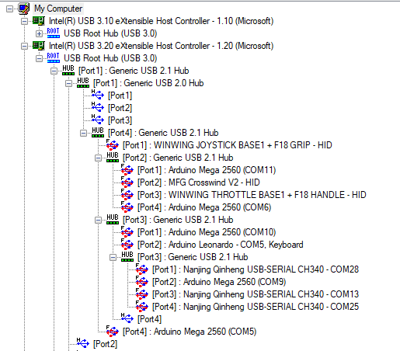

Good State

Restarting Arduino Boards
If USB Device View is started with Administrator rights, some of the USB Nodes can be restarted.

COM13
- Max7219
- PWM Console Flood
- Chart Light. Note chart light immediately resets to Chart Light Potentiometer
- Nextron
- Compass (after light test has completed)
Com 23
- Pixel Led

Switches not working
The input Arduinos now listen on UDP port 7795. If any packet is sent to this port, then debug packets will be sent to the Reflector. The debugs should capture both the initial change of the device state, and if a DCS BIOS mapping is associated, the DCS-BIOS message. This was heavily used to identify how to get the Parking Brake working.

Standby Instruments

If the OLEDs are not displaying on the Altimeter

Preflight System Check
As the simulator is a complex entity, there are plenty of things to go wrong. A basic sanity test script checks connectivity of simulator components.
The script is located in ‘/Python HW Link/pyHWLink_System_Check.py’
It uses the pythonping module.
It pings the local loopback (127.0.0.1), its own IP Address (172.16.1.10), Arduino Ethernet cards, Raspberry Pi the validates the correct wireless SSID (‘Shed’) is connected (obviously this is unique to my environment)

Systems Overview

The Hornet currently supports DCS and MSFS 2020. DCS provides full system capabilities, whilst MSFS 2020 supports a basic aircraft tooling. The bulk of the interfacing with DCS uses the Flight Panels fork of DCS-BIOS. Further details on API usage and development can be found in ‘Python HW Link – Design’ document.

The throttle and stick assembly are from WinWing (https://www.winwing.cn/en/JOYSTICK) and the rudder pedals are from MFG (https://mfg-sim.com/en/).

As the ADI is not natively rendered in DCS, Helios is used to generate the ADI. The Left and right DDIs along with the AMPCD can be easily exported, but views such the RWR/TEWS, do require a little more work to export.

Systems Design Approach

Where possible Off the Shelf building blocks and Open Source have been used to ensure longevity and adaptability of the pit. Code and Designs unique to the build (ie not Open Hornet components) are published in the Git Hub Repo (https://github.com/bnepethomas/bne-arduino-flight-simulator-interfaces). I’ll acknowledge now the filing system in the repo needs tidying up.

The repo holds a number of current and historical projects, which makes finding things ‘fun’ at times. The bulk of the software is divided into two regions, DCS-BIOS and Python HW Link. References to locations for the project will be relative to the root directory of the repo.

KICAD was used for PCB design. It is a fully integrated package which ensures a consistency between schematics and the PCB.

LibreOffice and Draw.io are used for documentation.

IP Addresses
String sMac = "A8:61:0A:67:83:03";

Board | Code | IP Address | MAC Address | COM Port
PC |  | 172.16.1.10
UIP OLED | UIP_UFC | 172.16.1.100 | 00:DD:3E:CA:36:99 | 11
UIP INPUT | UIP_INPUT_CONTROLLER | 172.16.1.101 | A8:61:0A:9E:83:01 | 25
PIXEL LED | LIP_UDP_TO_PIXEL_LED | 172.16.1.105 | A8:61:0A:9E:83:05 | 28
MAX7219 NETRON RELAY | UIP_MAX7219_NEXTRON_POWER_RELAY | 172.16.1.106 | A8:61:0A:9E:83:06 | 13
LEFT CONSOLE COMBINED | LEFT_CONSOLE_INPUT_CONTROLLER_V2 | 172.16.1.100 | A8:61:0A:67:83:00 | 5
GAUGES INSTRUMENTS | GAUGES_INSTRUMENT_CONTROLLER | 172.16.1.108 | A8:61:0A:67:83:08
RIGHT CONSOLE OLED DRVER | A10_RIGHT_CONSOLE_OLED | 172.16.1.109 | A8:61:0A:67:83:09 | 4
ETHERNET TO KEYBOARD | LIP_UDP_TO_KEYBOARD | 172.16.1.110 | A8:61:0A:9E:83:6E | 3
DIGITAL OUT, SERVER AND STEPPER | LIP_SERVO_STEPPER_DIGITAL_OUT | 172.16.1.111 | A8:61:0A:9E:83:6F | 9
RASPBERRY PI | GPS | 172.16.1.112
STANDBY INSTRUMENTS | STANDBY_INSTRUMENTS | 172.16.1.114 | A8:61:0A:9E:83:71 | 10
LIP CONTROLLER | LIP_CONTROLLER | 172.16.1.115 | A8:61:0A:9E:83:73 | TBA
Sim Controller | RIGHT_CONSOLE_SIM_CONTROL | 172.16.1.116 | A8:61:0A:9E:83:74
RIGHT CONSOLE INPUT | RIGHT CONSOLE INPUT | 172.16.1.103

Arduino Mapping
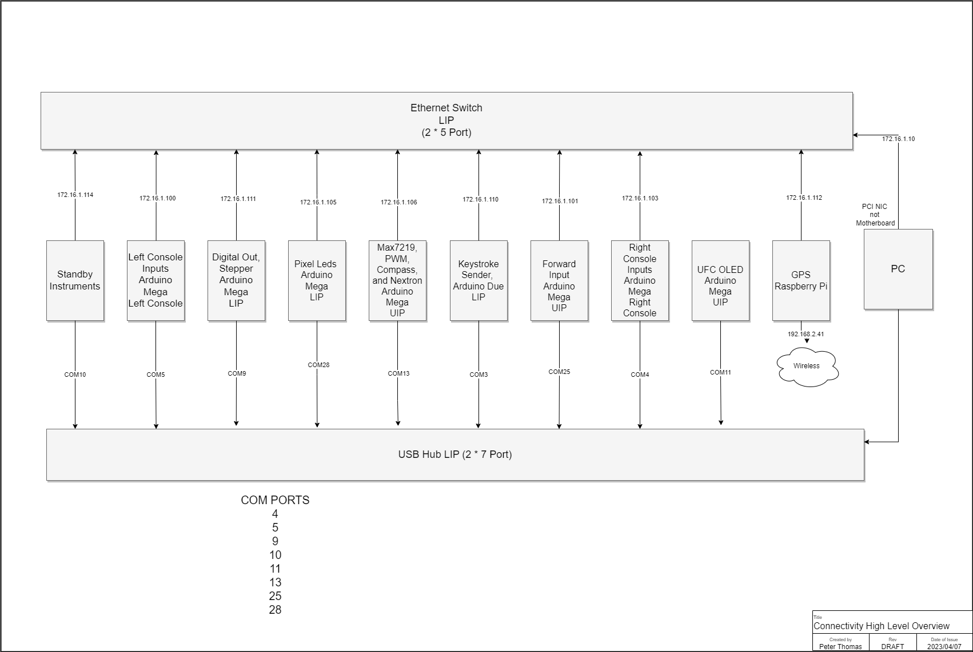

Right Console
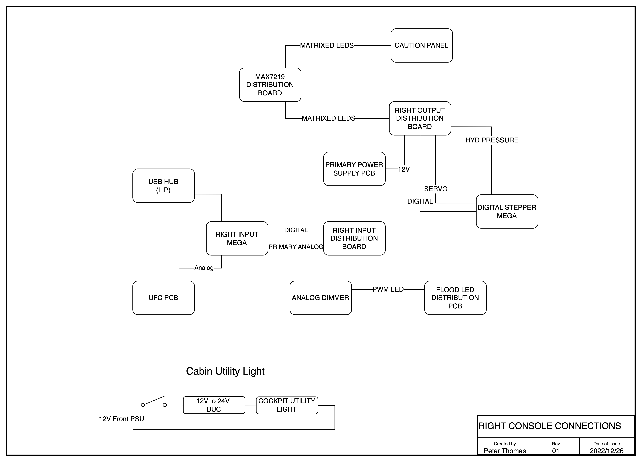
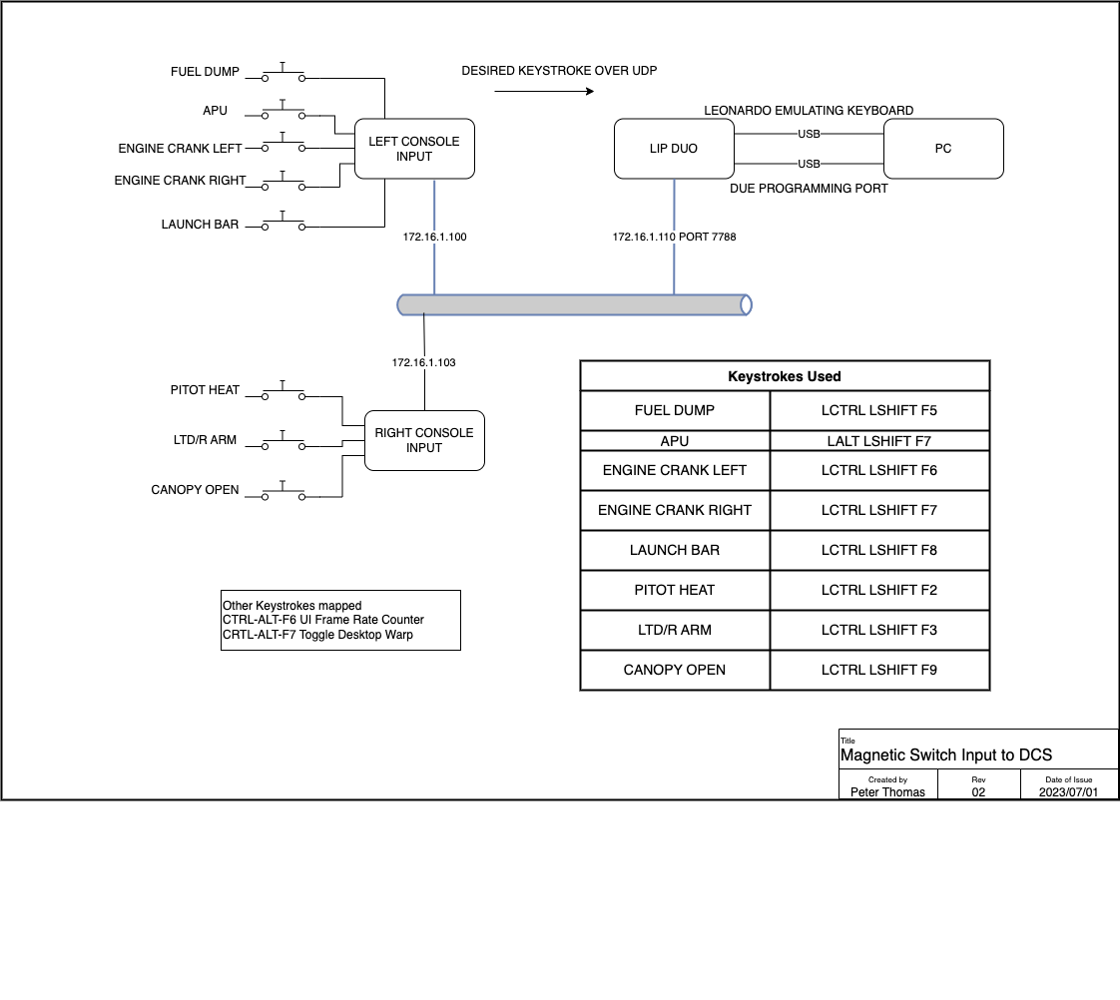

Power Distribution
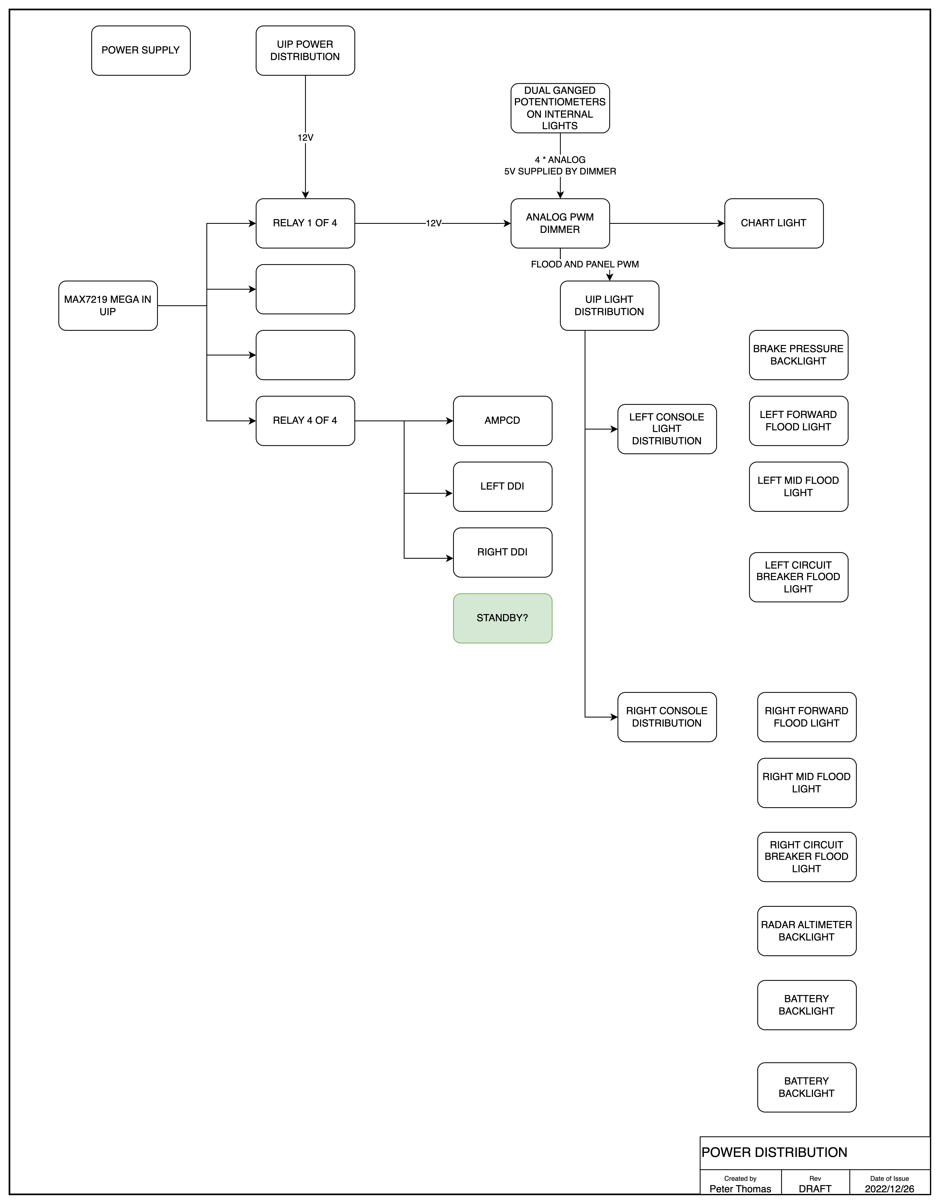
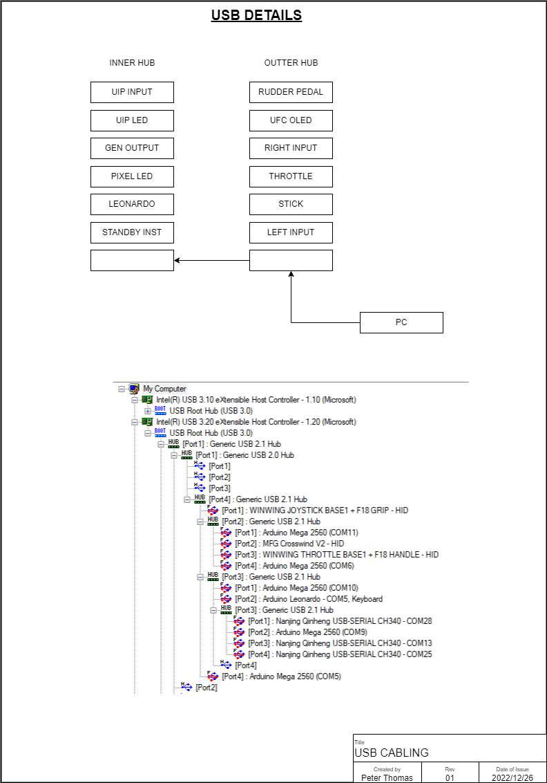

Text USB Tree

[2-2]: Generic USB 2.1 Hub
|FS-[2-2-1]: WINWING JOYSTICK BASE1 + F18 GRIP - HID
|---[2-2-2]: Generic USB 2.1 Hub
| |FS-[2-2-2-1]: Arduino Mega 2560 (COM11)- UFC OLED
| |FS-[2-2-2-2]: MFG Crosswind V2 - HID
| |FS-[2-2-2-3]: WINWING THROTTLE BASE1 + F18 HANDLE - HID
| \FS-[2-2-2-4]: Arduino Mega 2560 (COM4)- Right Console Input
|---[2-2-3]: Generic USB 2.1 Hub
| |FS-[2-2-3-1]: Arduino Mega 2560 (COM10)- Standby Instruments
| |HS-[2-2-3-2]: Arduino Due - COM3, Keyboard – Keyboard Sender
| |---[2-2-3-3]: Generic USB 2.1 Hub
| | |FS-[2-2-3-3-1]: Nanjing Qinheng USB-SERIAL CH340 – COM28 – Pixel Leds
| | |FS-[2-2-3-3-2]: Arduino Mega 2560 (COM9) – Digital Out Stepper
| | |FS-[2-2-3-3-3]: Nanjing Qinheng USB-SERIAL CH340 – COM13 – Max7219 Nextron
| | \FS-[2-2-3-3-4]: Nanjing Qinheng USB-SERIAL CH340 – COM25 – Fwd Input
| \HS-[2-2-3-4]
\FS-[2-2-4]: Arduino Mega 2560 (COM5) – Left Console Input

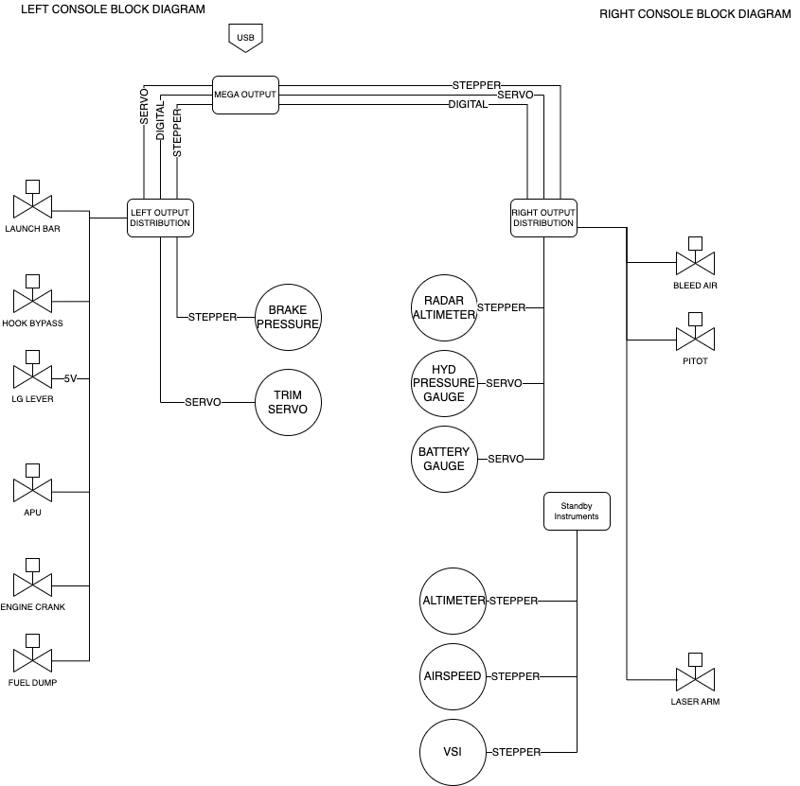

Hardware Design Approach

Whilst the ultimate goal is use as little USB connectivity as possible for simulator to pit communications, the bulk of the Arduino’s are currently connected with USB and Ethernet.

Switch and Analog Inputs

The bulk of the Switch inputs are multiplexed to an Arduino Mega. The input Mega’s are located in the Left and Right Consoles as well as the UIP. A small PCB takes the ports 22 to 53 to an Expansion PCB that is specific to the area it is serving. This approach enables code to be easily shared and reduces the amount of bespoke troubleshooting. The current exception to this is the Standby Instrument inputs, which now have a dedicated Mega which deals with both inputs and outputs on the Standby Instrument Panel.

The of the panels has a panel specific PCB that connects all services required for that panel aside from backlighting, as the backlighting PCB has its own connectors. This panel holds the diodes used to prevent ghosting of the switch inputs.

The bulk of the analog inputs are connected to the input Megas using the same connectivity approach as switch inputs. A small capacitor is used to reduce the amount of electrical noise received on the Mega. One exception to this is the approach used to dim the AOA indicators. The AOA dimmer sends updates over Ethernet to the Mega responsible for driving the LEDs. The original PCB design used a small connector to bring the Mega Analog inputs up to the primary analog input PCB. Later releases extended the lower PCB to include the analog inputs with a header bringing the analog inputs to the riser.

OLED, LED, Coil Outputs, Addressable RGB LEDs

The UFC displays are OLEDs driven using an I2C Multiplexor. Originally the Adafruit libraries where used, but ultimately found the U2G library offered the greatest performance and flexibility.

Almost all of the LEDs in the pit are driven using Max7219s. As the Max7219 does not support individual LED dimming, LED outputs are grouped into regions, enabling individual dimming of the region. This means that some of the possible outputs are not used. All of the Max7219s are located on a single PCB and are daisy chained. LED outputs (which are matrixed), are then either connected to the assembly (such as the AoA) or connected to the output distribution PCBs in the left and right console.

Magnetic Coil outputs use UN2003 Darlington Drivers arrays. This are located on output distribution PCBs in the Left and Right consoles.

Addressable RGB LEDs (WS2812) are used for backlighting. There are design options for AoA, but the final build used LEDs driven by Max7219.

Lighting System

Originally the backlighting areas not addressed with Lukes Backlighting was going to use an Aircraft PWM dimmer. This meant that some additional logic was needed to sense with the different lighting components were active. While looking at options it was discovered the Flight Panels DCS BIOS actually provided lighting levels for flood and backlights, not only state, but also brightness, and this included formation and strobe lights.

The simplest approach to deliver software controlled dimmable lighting was using MOSFETs. The Max7219 PCB was modified to add support for MOSFETs. The first attempt failed as not all Digital ports on the Arduino support PWM. Got it right in the second attempt.

Power to the lighting system, DDIs, and AMPCD (and soon to be standby instruments) is switched by relays driven from the Max7219 board. At the time of writing the 4th relay port is available, the plan is it use it to switch 5Vs for the Standby Instrument LCD.

#define RELAY_PORT_1 22
#define RELAY_PORT_2 23
#define RELAY_PORT_3 24
#define RELAY_PORT_4 25

#define BACKLIGHTING_RELAY_PORT RELAY_PORT_1
#define RIGHT_SCREEN_RELAY_PORT RELAY_PORT_2
#define LEFT_AND_AMPCD_SCREENS_RELAY_PORT RELAY_PORT_3

Text 1: Chart Light DCS BIOS Interface
void onChartIntLtChange(unsigned int newValue) {
if (newValue != 0) {
digitalWrite(BACKLIGHTING_RELAY_PORT, true);
} else {
digitalWrite(BACKLIGHTING_RELAY_PORT, false);
}
}
DcsBios::IntegerBuffer chartIntLtBuffer(0x755e, 0xffff, 0, onChartIntLtChange);

Text 2: Left DDI and AMPCD Power Logic Table
void CheckLeftAndAMPCDScreenPowerState() {

if ((LEFT_GEN_SWITCH_STATE == true) || ( BATTERY_SWITCH_STATE == true)) {
digitalWrite(LEFT_AND_AMPCD_SCREENS_RELAY_PORT, true);
} else {
digitalWrite(LEFT_AND_AMPCD_SCREENS_RELAY_PORT, false);
}
}

Text 3: Right DDI Power Logic Table
void CheckRightScreenPowerState() {

if ((RIGHT_GEN_SWITCH_STATE == true) || ( BATTERY_SWITCH_STATE == true)) {
digitalWrite(RIGHT_SCREEN_RELAY_PORT, true);
} else {
digitalWrite(RIGHT_SCREEN_RELAY_PORT, false);
}
}

DCS Systems Design Approach

DCS and Magnetic Switches
Currently the DCS F18 module doesn’t provide the same level of support as the A10. If the DCS-BIOS interface is used to set a switch position, the simulator thinks the switch is being physically held in position. This prevents it being automatically released. Because of this, a different approach is needed to support the magnetic switches. Instead of using DCS-BIOS a message is sent from the input Mega over Ethernet to an Arduino Due. The Arduino Due in turn sends keystroke to the PC.
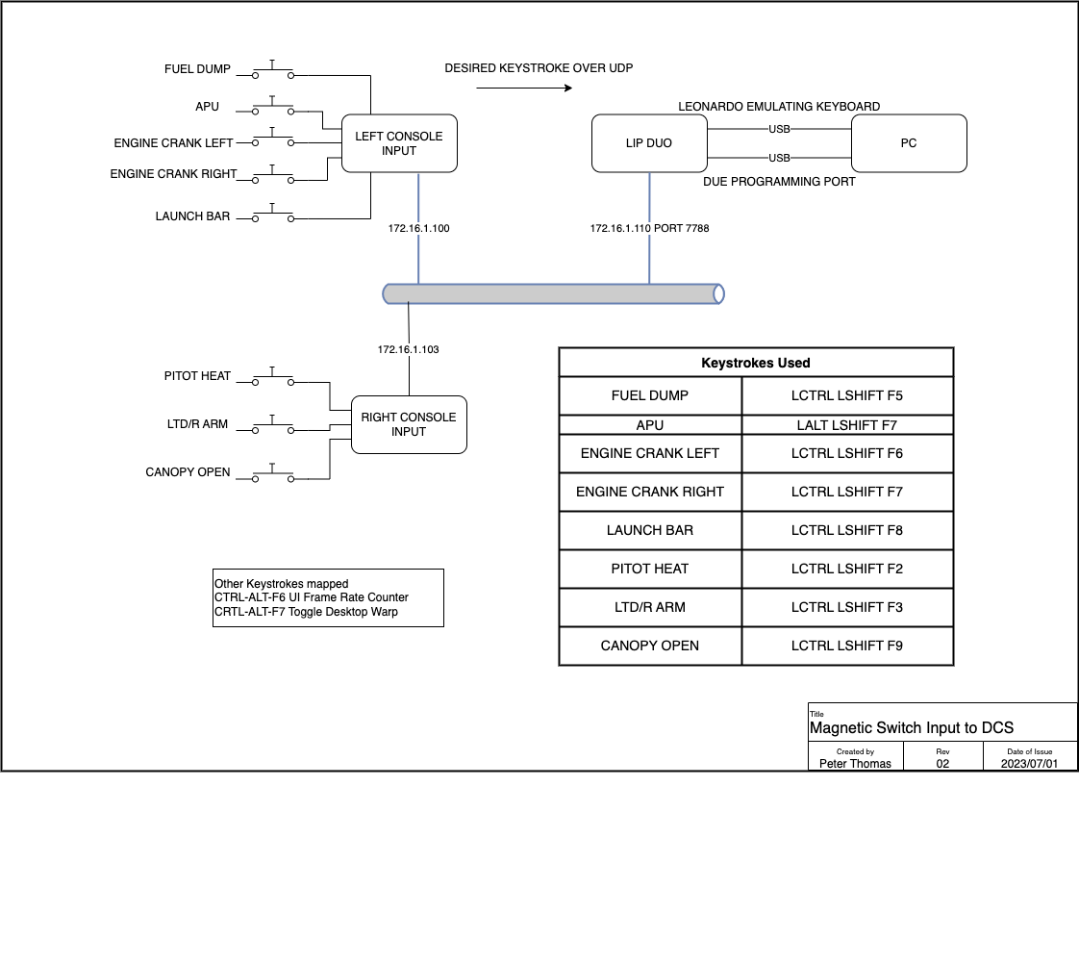

Other Software Modules

Flight Panels DCS-BIOS Fork
As the original author [FSF]Ian of DCS-BIOS is no longer maintaining DCS-BIOS, another team is maintaining a fork of it. Two of the DCS Flightpanels repositories are used in this project. One is the Arduino library, and the other is the PC side which sends the data streams to the Arduinos over USB. Whilst there is mention of Ethernet, specially multicast, it does not appear be heavily used.
https://github.com/DCSFlightpanels/dcs-bios
https://github.com/DCSFlightpanels/dcs-bios-arduino-library
Unlike the original DCS-BIOS, Flightpanel’s DCS-BIOS does support resuming a flight after edits, which seriously speeds up coding and troubleshooting as flights no longer need to be exited and restarted.
The PC monitoring GUI is BORT.
SOCAT is used to send data to Arduinos, a 32 and 64 bit is included, requiring you to copy the desired version to the folder above.
It is possible to create a shortcut of the CMD to the task bar, but it does require a bit of goofing around, you can’t simply drag a shortcut of the CMD file to the taskbar. The steps needed to achieve this are at the end of this document

BORT
Bort provides a monitoring framework for DCS as well as skeleton code for Arduino – currently Bortv3 is being used. It just runs as an executable, ie does snot need to be installed.

https://github.com/DCS-Skunkworks/Bort

Elagto Stream Deck

With dynamic graphics on buttons this hardware and software provides a way of lunching programs without needed to use a mouse.

Stream Deck profile from DCS
https://www.digitalcombatsimulator.com/en/files/3319467/

Added Keystrokes

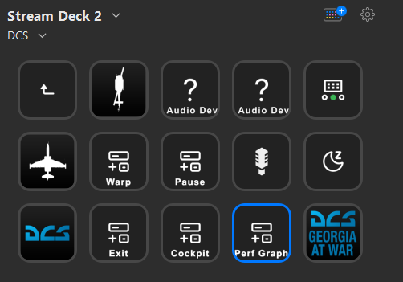

WARP – Ctl-Alt-F7
PAUSE – PAUSE
EXIT - ESC
COCKPIT – ALT-F1
PERF GRAPH – L-CTRL L-ALT F6

Helios
Helios, among other things, renders instrument and updates values using a LUA feed. Helios is now only needed for the ADI as the other steam instruments are no longer using a screen.
Helios itself
  - HeliosGit Repo https://github.com/HeliosVirtualCockpit/Helios
  - Installers - https://github.com/HeliosVirtualCockpit/Helios/releases/latest
  - Check out the wiki if needed - https://github.com/HeliosVirtualCockpit/Helios/wiki
  - Grab desired Profiles from Captain Zeens site http://www.captzeen.com/helios/downloads.asp
    - Using CaptZeen_FA18C_V3.1.helios16
https://github.com/HeliosVirtualCockpit/Helios/releases
Helios F18 profiles
http://www.captzeen.com/helios/f18.asp
Check out the wiki if needed - https://github.com/HeliosVirtualCockpit/Helios/wiki
Youtube Install Guide
https://www.youtube.com/watch?v=N0gCVIRwzos
Youtube Getting Started
https://www.youtube.com/watch?v=IfS0AtndXAM

Fly Elise
Fly Elise provides both design and operate capabilities for curved screens. The curved screen was designed using Immersive Designer PRO. Design Pro is able to generate monitor configuration files used by DCS, and hopefully MSFS 2020 in the future.
I’m still yet to get to the bottom of why I see image drift when using the projectors. It could be due to the following:
- Slight movement in the ceiling
- Temperature changes in the projector itself
- The projector reverting to automatic keystone correction. Generally for the simulator it is recommended that automatic keystone correction is disabled.
Explicitly setting hot-keys should be done for Fly Elise, as the default mappings may conflict with the default settings in the setting in DCS or MSFS 2020.
Currently the multi-view capabilities in MSFS aren’t geometrically accurate, so it is an experimental feature.
When running DCS you will get a very unusual experience when you enter the flight. Its important not to enable simulator specific capabilities until the flight has started. Once the flight is loaded the screen will look very distorted, but once the simulator capabilities are enabled the view will come good.
Blog Updates regarding MSFS 2020

https://fly.elise-ng.net/blog/multi-view-perspective-correction/ - July 16, 2021
Designing the projection setup for 100% accurate and true geometric correction for 3D game engines and simulation setups requires even more attention and design considerations. Computer generated graphics and perspective views have a limitation of the total field of view (FOV) that can be rendered to a single view. In practice, rendering FOVs of 100 or more degrees will result in a “pinch” distortion and unusable view. As a consequence, creating a visual projection setups with FOVs of 180 or larger horizontal FOV, requires a 3D game engine to generate multiple views. Each view will be generated with a FOV of less than 100 degrees and combined and edge by Immersive Display PRO.
Almost all flight simulators P3D, DCS, X-Plane as well as all graphics engines like Unity, Unreal, etc.. already support configurable multi-view rendering.
However, combining multiple perspective views as one continuous undistorted image on a curved projection screen requires additional image geometric correction (stretching and squeezing) which is dependent on the physical projection setup, projection screen, projectors light path and the designed eye-point.
Designing a projection setup for multi-view projection involves additional analysis for projector pixel utilization and image stretching from a design eyepoint.
The latest version of Immersive Designer PRO introduces a new analysis module for analysis and evaluation of the perspective image pixel utilization and stretching.

Component Details

Arduinos and Ethernet Shields
In earlier projects I have used clone Arduinos and Ethernet shields, had some real issues with reliability of the Ethernet shields. For the Hornet ran with genuine Arduino Megas and Ethernet Shields (v2). The Ethernet shields have been solid.

A benefit of using genuine Arduinos is they report a serial number, which becomes very useful when you have eight possible devices to program. More recently discovered the Elegoo Mega which is well built and also provides serial numbers.

The newer generation of controllers in the pit changes the mounting approach where the Mega becomes the daughter board to the controller and uses an Ethernet module which uses the same chip and library as the Ethernet shield.

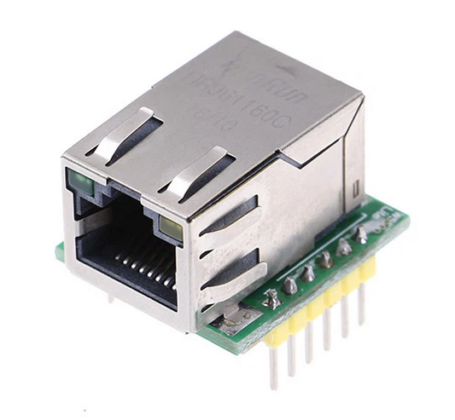

External Lights
The external lights (Position, Formation and Navigation) are driven from the MOSFET PWM PCB.
PWM dimming using Arduino driven MOSFETs are used with the desired output level being acquired from Flightpanel’s DCS-BIOS. Of note is that not all Arduino Mega Digital pins support PWM.

Flood Lighting

Flood lights are distributed throughout the pit. They are close as possible to the original components. All have been printed using PLA+ on the Prusa. A Cold White filament was used as it offers great reflectivity. Led Bulbs and bulb holders where used to reduce the amount of heat.
PWM dimming using Arduino driven MOSFETs are used with the desired output level being acquired from Flightpanel’s DCS-BIOS. Of note is that not all Arduino Mega Digitals pins support PWM

GPS
The GPS is not native to the Hornet, but is helpful for navigation and approaches. It is driven by both DCS and MSFS 2020. The Lowrance Air Map 2000C is capable of receiving NEMA (National Marine Electronics Association) Sentences over an RS232 interface, which means it can be driven by an external source such as a high resolution GPS or a simulator.
In other Sims I’ve used FSUIPC and C# applications to acquire Lat Long information. As the Hornet project is a test bed for several new techniques and tools, a new approach was used for driven the GPS.

dofile(lfs.writedir()..[[Scripts\DCS-BIOS\BIOS.lua]])

package.path = package.path..";.\\LuaSocket\\?.lua"
package.cpath = package.cpath..";.\\LuaSocket\\?.dll"

socket = require("socket")

gps_export_port = 13136
gps_export_host = "172.16.1.112"
gps_export_socket = require("socket")
gps_export_con = socket.try(gps_export_socket.udp())
gps_export_socket.try(gps_export_con:settimeout(.001))
gps_export_socket.try(gps_export_con:setpeername(gps_export_host,gps_export_port))

function LuaExportActivityNextEvent(t)

local tNext = t

local gps_export_flightData = {}
-- LATITUDE
table.insert(gps_export_flightData,"latitude:"..LoGetSelfData().LatLongAlt.Lat)
-- LONGITUDE
table.insert(gps_export_flightData,"longitude:"..LoGetSelfData().LatLongAlt.Long)
-- ALTITUDE SEA LEVEL(MTS TO FT)
table.insert(gps_export_flightData,"altitude:"..LoGetAltitudeAboveSeaLevel())
-- TRUE AIRSPEED (M/S TO KNOTS)
table.insert(gps_export_flightData,"airspeed:"..LoGetTrueAirSpeed() * 1.94)
-- HEADING (RAD TO DEG)
table.insert(gps_export_flightData,"magheading:"..LoGetSelfData().Heading * 57.3)
gps_export_packet = gps_export_flightData[1] .. "," .. gps_export_flightData[2] .. ","
gps_export_packet = gps_export_packet .. gps_export_flightData[3] .. ","
gps_export_packet = gps_export_packet .. gps_export_flightData[4] .. ","
gps_export_packet = gps_export_packet .. gps_export_flightData[5]
gps_export_socket.try(gps_export_con:send(gps_export_packet))

tNext = tNext + 0.3

return tNext

end

The GPS itself is connected to a Raspberry Pi with a simple PCB (Pi GPS Serial), (hosting a Max232 to convert 3.3V Logic levels to RS232.
The MSFS 2020 interface uses a Python module to interface to Sim Connect (https://github.com/bnepethomas/Python-SimConnect). This was forked off https://github.com/odwdinc/Python-SimConnect which at the time had an error which prevented it from working with MSFS2020. That error has since been resolved.
One learning is when updating Python Modules – The mod that has been install (for Windows) lives in c:\users\admin\Local\Programs\Python\Python311\Lib\site-packages\module-name. So if you are updating the module to add capabilities, don’t forget to copy the modified module back to the git repo.

Left Console – FCS

The Rudder trim assembly has a press to Trim button which rotates the assembly to a take-off trim position. This is driven by a servo, which would normally prevent the pilot from manually turning the trim knob. To address this restriction, the servo is ‘disconnected’ in software when not being driven by the take-off trim action.
On startup the Trim knob is shifted just off centre, and then returned to centre after a short delay. The take-off trim action is sensed by the press of the Trim Button (onToTrimBtnChange)
Servo TRIM_servo;
#define TrimServoPin 12
#define TRIM_servo_Off_Center_Pos 800
#define TRIM_servo_Center_Pos 1450

void CenterTrimServo() {
TRIM_servo.attach(TrimServoPin);
TRIM_servo.writeMicroseconds(1100); // set servo to "Mid Point"
delay(10);
TRIM_servo.writeMicroseconds(800); // set servo to "Mid Point"
delay(300);
TRIM_servo.detach();
}
void onToTrimBtnChange(unsigned int newValue) {
if (newValue == 1) {
CenterTrimServo();
}
}
DcsBios::IntegerBuffer toTrimBtnBuffer(0x74b4, 0x2000, 13, onToTrimBtnChange);
void setup() {
TRIM_servo.attach(TrimServoPin);
// set servo to just off Centre
TRIM_servo.writeMicroseconds(TRIM_servo_Off_Center_Pos);

delay(1000);
// set servo to centre
TRIM_servo.writeMicroseconds(TRIM_servo_Center_Pos);
delay(500);
TRIM_servo.detach();
}
To enable the pilot to turn the Rudder trim the servo The Rudder trim servo and potentiometer u

Panel Backlighting

The Panels are driven by a hardware solution developed by Luke. It uses PCBs with SMD (Surface Mounted) LEDs, which enable knobs to be effectively backlit, something that is difficult when using through hole LEDs.

The LEDs used are from the WS2812B family, who do not have a separate clocking or data load pin. This has the major benefit of enabling 100’s of LEDs to be driven with a four wire interface (Power, Ground, Data-In, Data-Out). It does however introduce a timing consideration, the LEDs expect a constant data feed when updating, i.e. the Arduino library (FastLED) should not be interrupted when doing an update. If it is interrupted all sorts of strange colours and state is encountered, often toward the end of the led chain. As the Arduino DCS-BIOS library uses interrupts to receive serial data over the USB interface, and most Arduino CPUs are only single threaded the DCS-BIOS and FastLED are not good neighbours with long LED chains.

With a pretty full fleet of Pixel Leds (1500 in my test setup) - it takes 50mS to update them - so during that time an interrupt from serial comms through DCS BIOS is likely to cause a hiccup. Reduce the number of pixels down to 30 and the update time reduces to 3mS.

This challenge was solved by splitting DCS-BIOS and the FastLED library onto two Arduino’s with the DCS-BIOS Arduino sending lighting updates over Ethernet to the FastLED library.

Some devices are backlight using PWM, this includes some of the first generation of gauges. Later gauges (eg Standby Instruments) use the 5mm Through hole WS2812 LEDs.

As the UIP chain of 2812s not only does backlighting but also lights the indicators on the Master mode panel, the code needs to deal with count of 2812s on each PCB

From the OpenHornet Repo at May 2025 it looks like there are 29 2812s on the Master Arm Panel

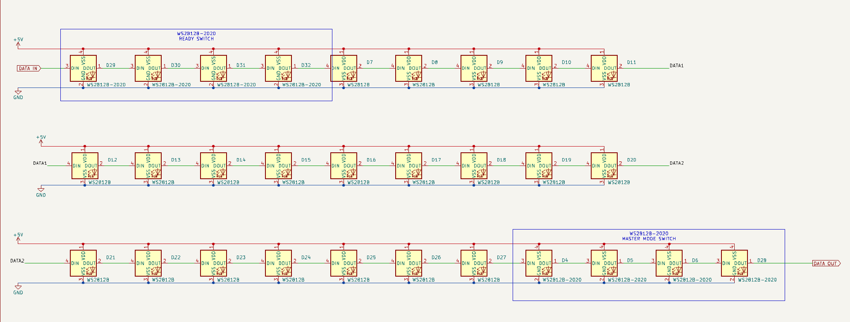
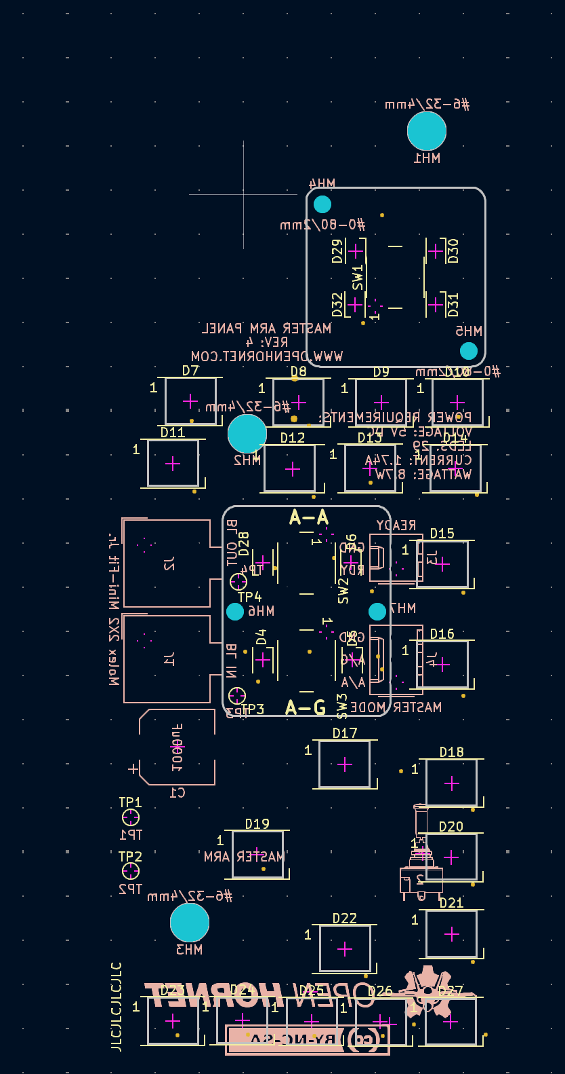

// Defining how many pixels each backlighting connector has connected, if a connector is not used set it to zero.
// Led Counts for LIP and UIP Panels
#define ECM_JETT_LED_COUNT 78
#define STANDBY_LED_COUNT 8
#define VIDEO_RECORD_LED_COUNT 16
#define PLACARD_LED_COUNT 8
#define MASTER_ARM_LED_COUNT 29
#define HUD_CONTROL_LED_COUNT 56
#define SPIN_RECOVERY_LED_COUNT 53

As one of the 2812s had failed on the Master Arm – a quick recheck is needed. Separate chains are used for UIP and LIP.

const int UIP_CONSOLE_LED_COUNT = MASTER_ARM_LED_COUNT + HUD_CONTROL_LED_COUNT + SPIN_RECOVERY_LED_COUNT;

Master Arm is the first of the panels in the chain

const int MASTER_ARM_START_POS = 0;

The indicators sit at these locations

// Special Led Positions on LIP and UIP Panels
#define MASTER_ARM_READY_1 0
#define MASTER_ARM_READY_2 2
#define MASTER_ARM_DISCH_1 1
#define MASTER_ARM_DISCH_2 3
#define MASTER_ARM_AA_1 25
#define MASTER_ARM_AA_2 26
#define MASTER_ARM_AG_1 27
#define MASTER_ARM_AG_2 28

And are updated by the following code blocks

void Update_MASTER_ARM_DISCH_READY() {

if (MASTER_ARM_DISCH_READY == true) {
UIP_CONSOLE_LED[MASTER_ARM_START_POS + MASTER_ARM_READY_1] = CHSV(CHSVYellow, 255, warningBrightness);
UIP_CONSOLE_LED[MASTER_ARM_START_POS + MASTER_ARM_READY_2] = CHSV(CHSVYellow, 255, warningBrightness);
} else {
UIP_CONSOLE_LED[MASTER_ARM_START_POS + MASTER_ARM_READY_1] = CHSV(CHSVYellow, 255, 0);
UIP_CONSOLE_LED[MASTER_ARM_START_POS + MASTER_ARM_READY_2] = CHSV(CHSVYellow, 255, 0);
}
LedUpdateNeeded = true;
}

Which is in turn triggered by

void ProcessReceivedString() {
..
if (ParameterNameString.equalsIgnoreCase("MASTER_ARM_DISCH_READY")) {
if ((Debug_Display || bLocalDebug) && Serial_In_Use) Serial.println("Found MASTER_ARM_DISCH_READY");
tempVar = ParameterValue.toInt();
if (tempVar == 1)
MASTER_ARM_DISCH_READY = true;
else
MASTER_ARM_DISCH_READY = false;
Update_MASTER_ARM_DISCH_READY();
}

The triggering packet is sent from LIP_SERVO_STEPPER_DIGITAL_OUT.ino

void onMcReadyChange(unsigned int newValue) {
if (newValue == 1) {
SendIPString("MASTER_ARM_DISCH_READY=1");
} else {
SendIPString("MASTER_ARM_DISCH_READY=0");
}
}
DcsBios::IntegerBuffer mcReadyBuffer(0x740c, 0x8000, 15, onMcReadyChange);

The backlighting levels are derived from DCS-BIOS, the Flight Panels fork presents these values, whereas the original DCS-BIOS does not.

A design note when using ground and power planes with PCBs, Thermal Reliefs should be included as this reduces the amount of heat needed to solder or remove a device. For reference - https://resources.pcb.cadence.com/blog/2021-pcb-thermal-relief-guidelines-for-effective-layouts.
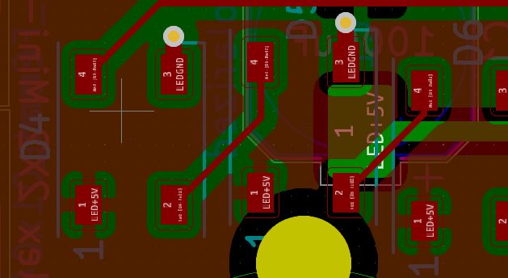
The 5mm NeoPixel LEDs used in the Standby instruments use a different colour encoding, From (https://www.adafruit.com/product/1938), ‘These are "RGB" instead of "GRB" format used in the 5050-sized LEDs you are so used to’.

An alternative approach is simply using 3mm LEDs in groups of three. With a target max current of 15mA per chain of LEDs the following resistors are used

Table 1: Backlighting Resistor Values
Number of LEDs in  chain | Resistor value
3 | 150 ohm
2 | 330 ohm
1 | 560 ohm

Power Supplies and Power Management

A single PC power supply powers all devices in the pit. This includes the USB Hubs, Backlighting, and Monitors.
Some of the power rails are controlled by relays to give a full dark pit experience. Whilst there was concern about the monitors loosing their position on the PC – it appears to hold
The current orientation of the power supply is not ideal, with the fans bearings making a noise on initial power up. Ultimately it should be relocated or reorientated.
The original plan was to use different sized connectors for the 5V and 12V services. Despite the best efforts, still managed to mix them up, so in addition to attempting to use different size connectors, the following colour coding is used
5V Grey
12V Red
The Left Console, Right Console, UIP, and LIP have power distribution PCBs.

Rudder Pedals
The pedals are MFG Crosswinds, and are beautifully engineered. The optional Damper is well worth the investment. The footrests aren’t from MFG, at the time of purchase, a team on the DCS forums was manufacturing F-16 footrests (https://forum.dcs.world/topic/256148-mfg-crosswind-f-16-combat-pedals/)

The pedals are mounted on a plate driven by a motor, enabling the pedals to be adjusted using a switch in the forward lower panel assembly. Limit switches are used. The plate is mounted on a pair of rails.

Throttle Assembly
As the WinWing throttle was not part of the original Open Hornet design the panels to the left and forward of the throttle required modification.
The throttle was removed from its outer enclosure, and the backlighting was modified, in that is not longer driven by the WinWing electronics, but instead is driven by the custom PWM (Pulse Width Modulation) dimmer. Additional resistors were added to allow the LEDs to be driven by 12V.

Right Console Utility Light
The light is a genuine Utility Light with a 24V bulb. It is driven by an inverter which has its power supply controlled by a near-by switch.

Air to Air and Air to Ground Panel

This panel is a little unusual in that the indicators for the air to ground and air to air buttons are also 2812s which means they are not driven by the Max7219 framework.

Right Console Altimeter
This was kindly put together by Ben.
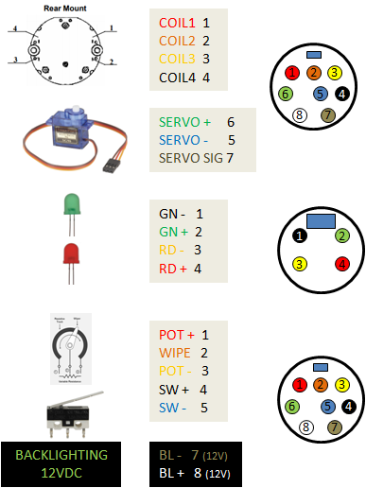

Standby Instruments
The standby instruments are driven by a separate Arduino. The code used is ‘STANDBY_INSTRUMENTS’

If logging to the UDP_Reflector is enabled the following will be seen on startup. Of note is the discovery of I²C devices on port 0 and 1 at address 0x3c (the oleds), and all three steppers finds a zero point.
2022-12-30 09:54:10,267:INFO:Payload: b'TCA Port #0\r\n'
2022-12-30 09:54:10,270:INFO:Payload: b'Found I2C 0x3c\r\n'
2022-12-30 09:54:10,273:INFO:Payload: b'Found I2C 0x70\r\n'
2022-12-30 09:54:10,276:INFO:Payload: b'TCA Port #1\r\n'
2022-12-30 09:54:10,285:INFO:Payload: b'Found I2C 0x3c\r\n'
2022-12-30 09:54:10,293:INFO:Payload: b'Found I2C 0x70\r\n'
2022-12-30 09:54:10,296:INFO:Payload: b'TCA Port #2\r\n'
2022-12-30 09:54:10,312:INFO:Payload: b'Found I2C 0x70\r\n'
2022-12-30 09:54:10,315:INFO:Payload: b'TCA Port #3\r\n'
2022-12-30 09:54:10,331:INFO:Payload: b'Found I2C 0x70\r\n'
2022-12-30 09:54:10,335:INFO:Payload: b'TCA Port #4\r\n'
2022-12-30 09:54:10,350:INFO:Payload: b'Found I2C 0x70\r\n'
2022-12-30 09:54:10,353:INFO:Payload: b'TCA Port #5\r\n'
2022-12-30 09:54:10,370:INFO:Payload: b'Found I2C 0x70\r\n'
2022-12-30 09:54:10,373:INFO:Payload: b'TCA Port #6\r\n'
2022-12-30 09:54:10,389:INFO:Payload: b'Found I2C 0x70\r\n'
2022-12-30 09:54:10,391:INFO:Payload: b'TCA Port #7\r\n'
2022-12-30 09:54:10,407:INFO:Payload: b'Found I2C 0x70\r\n'
2022-12-30 09:54:10,410:INFO:Payload: b'I2C scan complete\r\n'
2022-12-30 09:54:11,175:INFO:Payload: b'Looking for Altimeter Zero\r\n'
2022-12-30 09:54:13,174:INFO:Payload: b'Found Zero\r\n'
2022-12-30 09:54:13,226:INFO:Payload: b'Looking for Airspeed Zero\r\n'
2022-12-30 09:54:15,174:INFO:Payload: b'Found Airspeed Zero\r\n'
2022-12-30 09:54:15,181:INFO:Payload: b'Looking for VVI Zero\r\n'
2022-12-30 09:54:17,428:INFO:Payload: b'Found VVI Zero\r\n'

UIP – AOA

The AOA Brightness is handled in a special way due to theDCS-BIOS behaviour at the time the pit was built. This did require a separate Max7219 to be used. A separate UDP port is used to listen for brightness updates on the Arduino servicing the Max7219s (Hornet Forward Output Upper Shield)
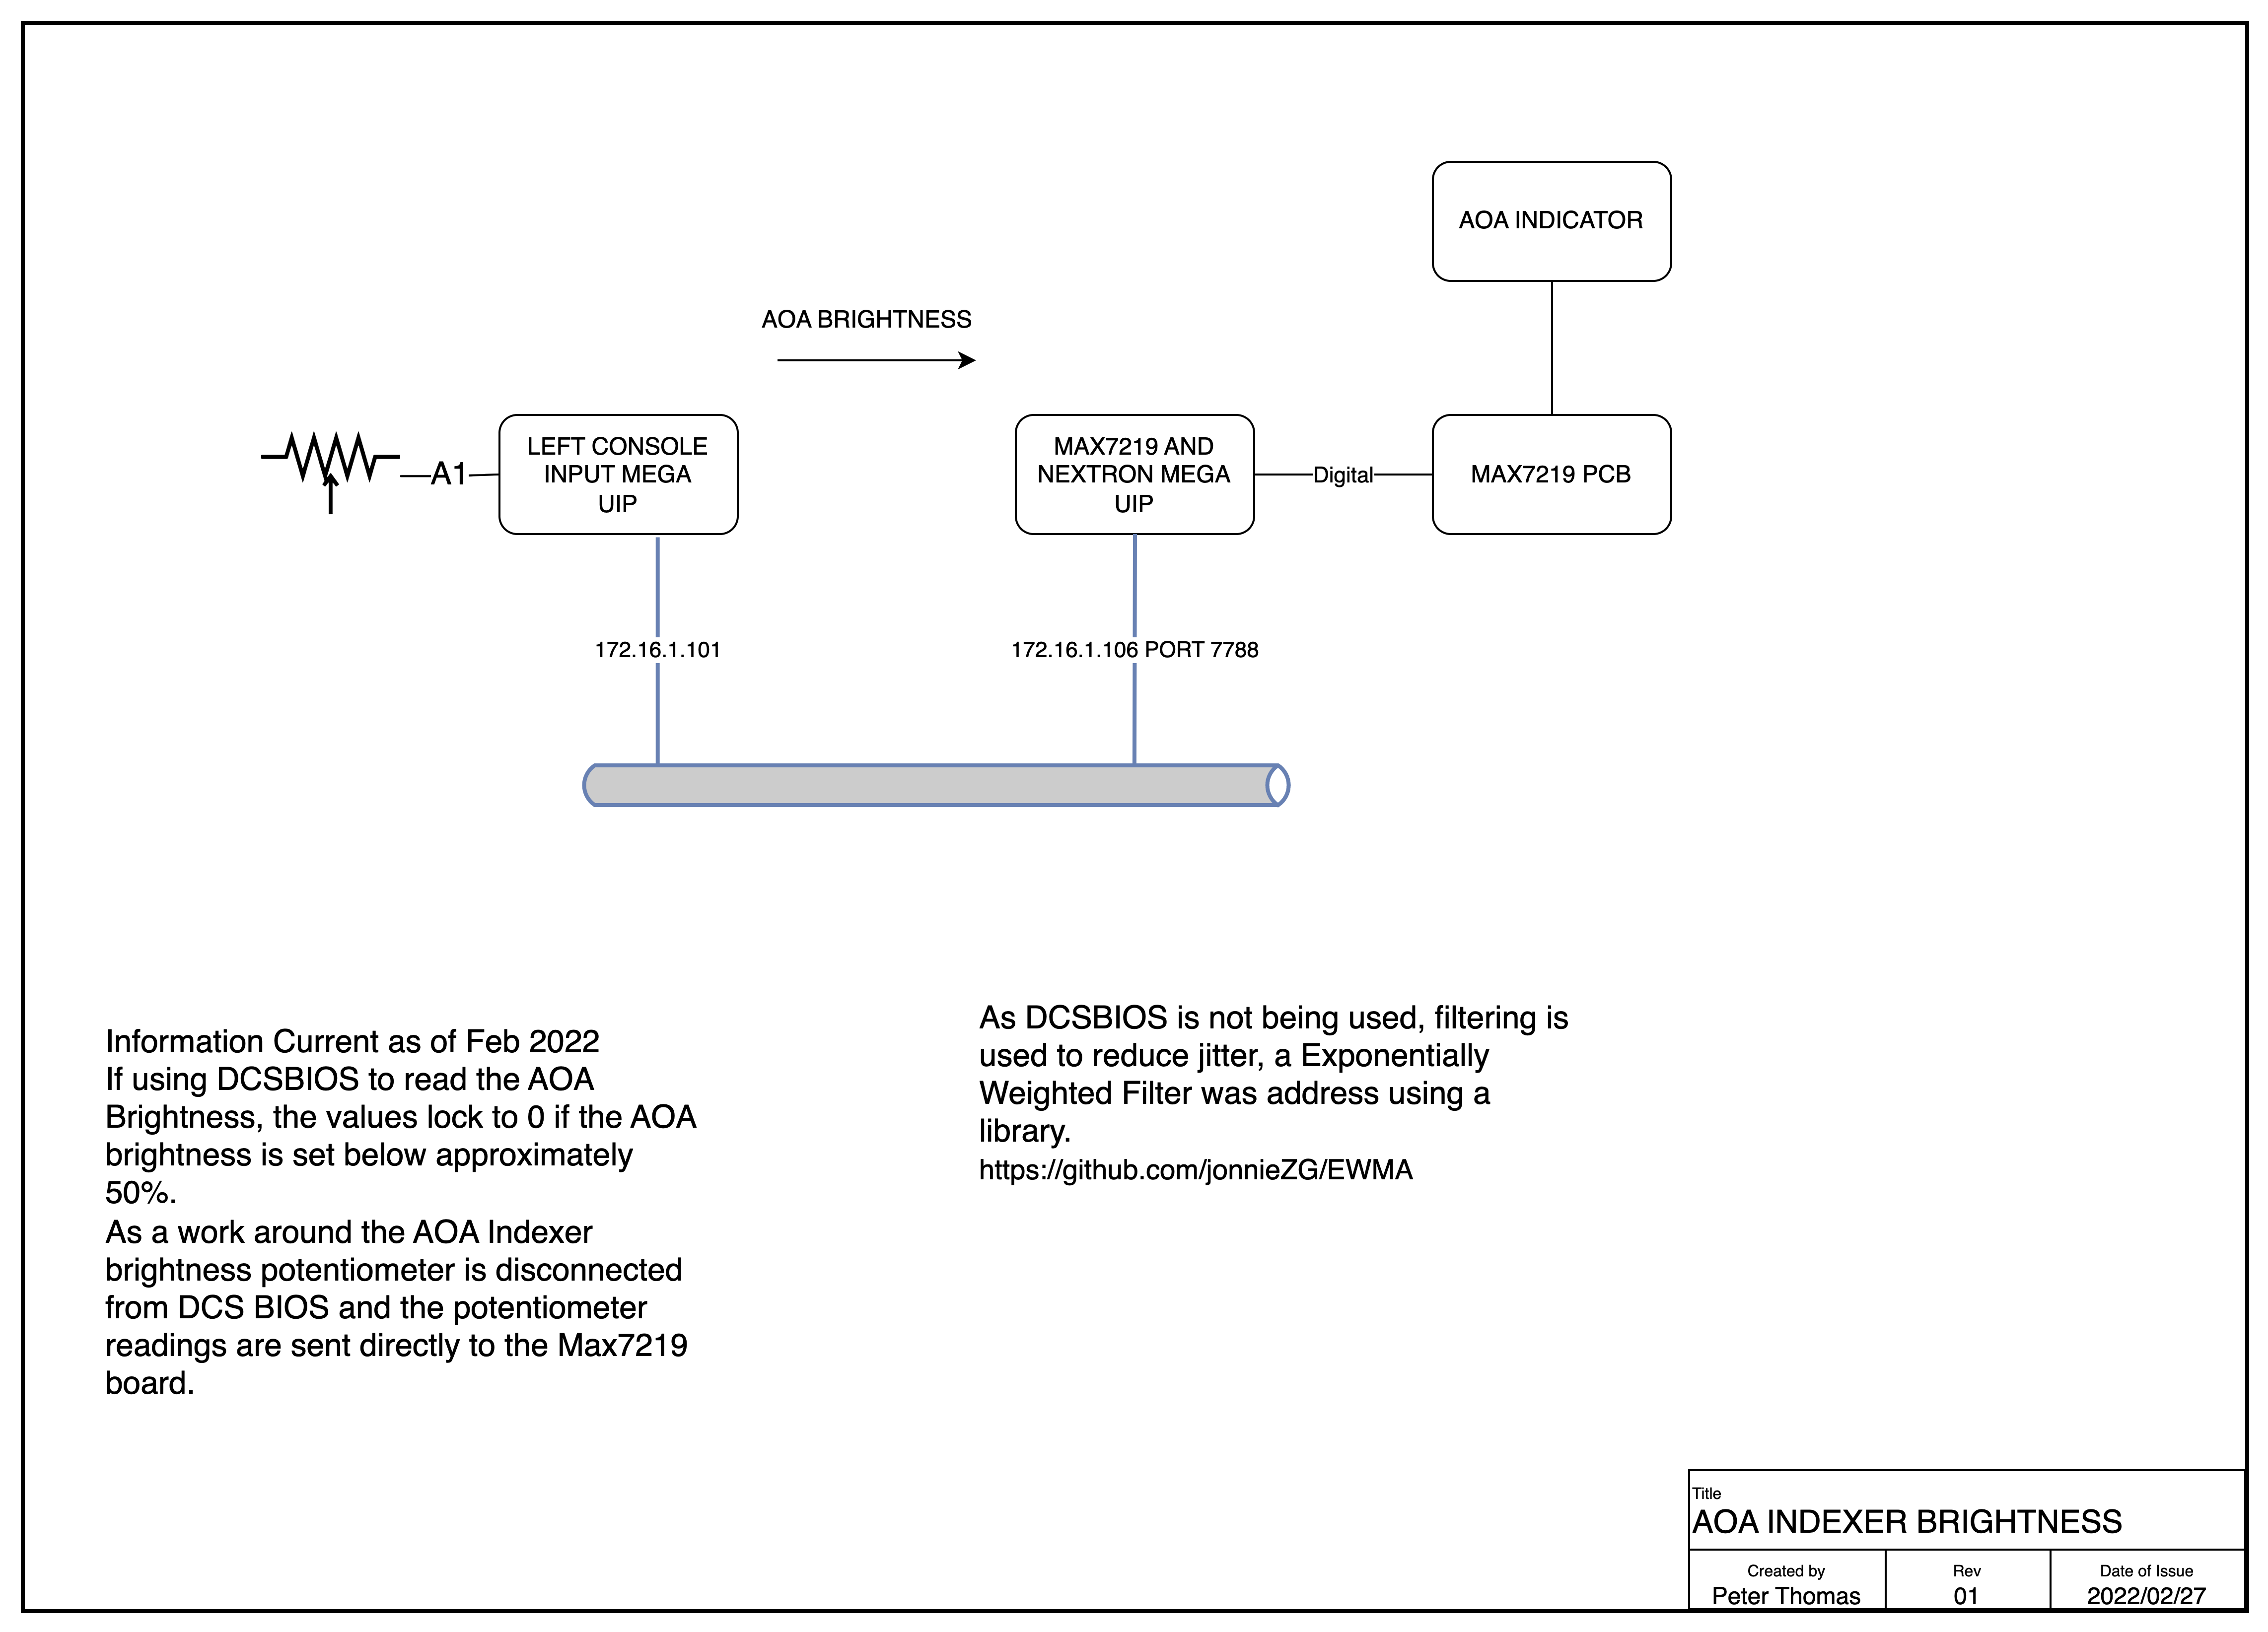

Software Modules

Computer Specifications

The following capabilities are desired
- Dual Wired Ethernet Interfaces, one for the Arduinos, the other for high performance connectivity such as last software updates and over the wire backups.
- WiFi interface for general connectivity
- Sound card with front and rear ports
- Six USB Ports
- Removable SSDs to facilitate high performance backups and swapping of simulator personalities (eg swap between DCS A10 and F16)
- Three high performance HDMI interfaces for the primary screens
- Ideally an HDMI port for the operators screens
- Four HDMI ports for the DDIs, AMPCD, and the standby ADI and RWR.
- An additional three video ports for the mirrors.

Computer Video Sub-system

With a minimum eight video ports there are some challenges in meeting these requirements. If mirrors are desired, a total of 11 ports are needed.
The original PC had a Nvidia 2080TI and a smaller three port Nvidia.
Ben found a four Port USB-3 video card which provides solid performance for DDIs and AMPCDs. The Startech USB32HD4 USB 3.0 to 4 HDMI Adapter - Quad Monitor lands around AU$270.

2023 Computer Specification
The PC was originally running a Nvidia 2080, it is intended to refresh the PC with a higher specification video card as a number of Blue Screens had occurred leading to the original PC not being able to boot.
The replacement PC is this configuration.
- Intel S1700 Core i9 13900K 24 Core CPU BX8071513900K
- Corsair iCUE H150i RGB ELITE Liquid CPU Cooler CW-9060060-WW
- MSI S1700 E-ATX MEG Z790 ACE DDR5 Motherboard
- 64GB DDR5 (2x32G) Corsair 5200MHz CMT64GX5M2B5200C40 Dominator Platinum RGB RAM
- Samsung 990 PRO PCIe 4.0 NVMe M.2 SSD 2TB - MZ-V9P2T0BW
- Nvidia Quadro T600 4GB PCIe Video Card 900-5G172-2520-000
- Gigabyte RX7900XTX 24GB PCIe Video Card GV-R79XTX-24GC-B
- Corsair Full ATX Obsidian 1000D Tempered Glass Case Black (No PSU) PN CC- 9011148-WW
- 120mm Noctua NF-A12x25 FLX 2000RPM Fan
- 1200 Watt Thermaltake Toughpower GF3 Gen5 Power Supply PS-TPD-1200FNFAGA-4
- Microsoft Windows 11 Home 64bit DVD KW9-00632

The Curved Screen and Projectors

The curved screen was supplied by Mocomtech (https://mocomscreens.com). It has a radius of 1500m and a height of 1600mm. Once the design was complete using fly Elise Design Pro, the process of ordering and shipping was very smooth.

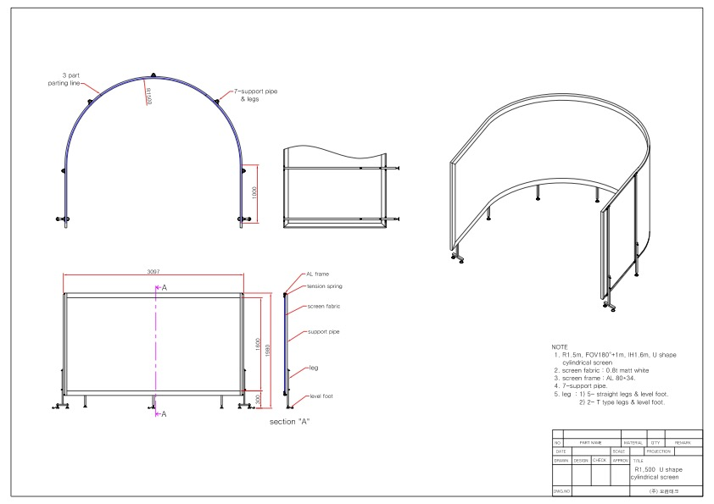
Three BENQ Short Throw 4K Projectors are used. With the high datarate associated with the 4K screens I found the older 10m HDMI leads no longer provided a reliable connection. I also have challenges with the Displayport to HDMI Adaptors.

Printed Circuit Boards and Software

Left Console

Pi GPS Serial
This PCB converts the Raspberry Pi 3.3V Logic Levels to RS232 using a MAX232. It also has connectivity for SPI interfaces and a digital output for the 737 Stick Shaker.
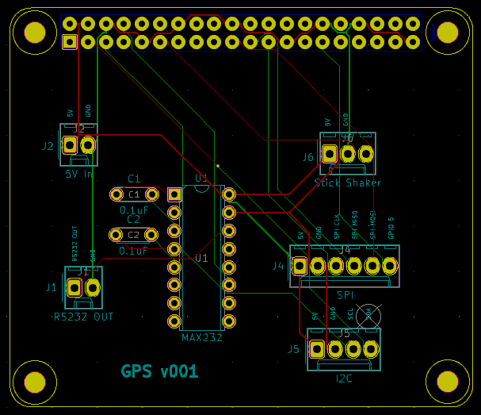
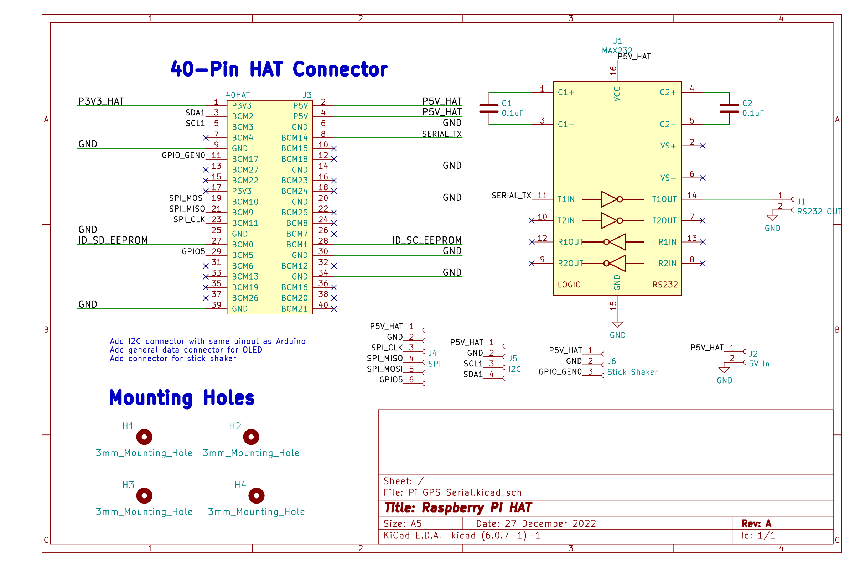

UIP

Hornet Forward Output Upper Shield
This shield drives the Max7219 chain, PWM, Nextion, Compass, and Relay outputs. As of December 2022 it is version 5. Like many of the Mega shields in this project, the board is designed so it can be separated to support an Ethernet Shield. A 12V jumper is needed to connect the 12V rail between the two boards.

The PWM Dimmer drives flood lights, External lights and some of the gauge backlighting. The Mega only supports PWM on ports 2-13 and 44-46 (had to update the board as originally thought PWM was available on all Digital IO pins). MOSFETs drive the LEDs.
4 Ports drive relays which assist in providing a lights out experience for the pit.

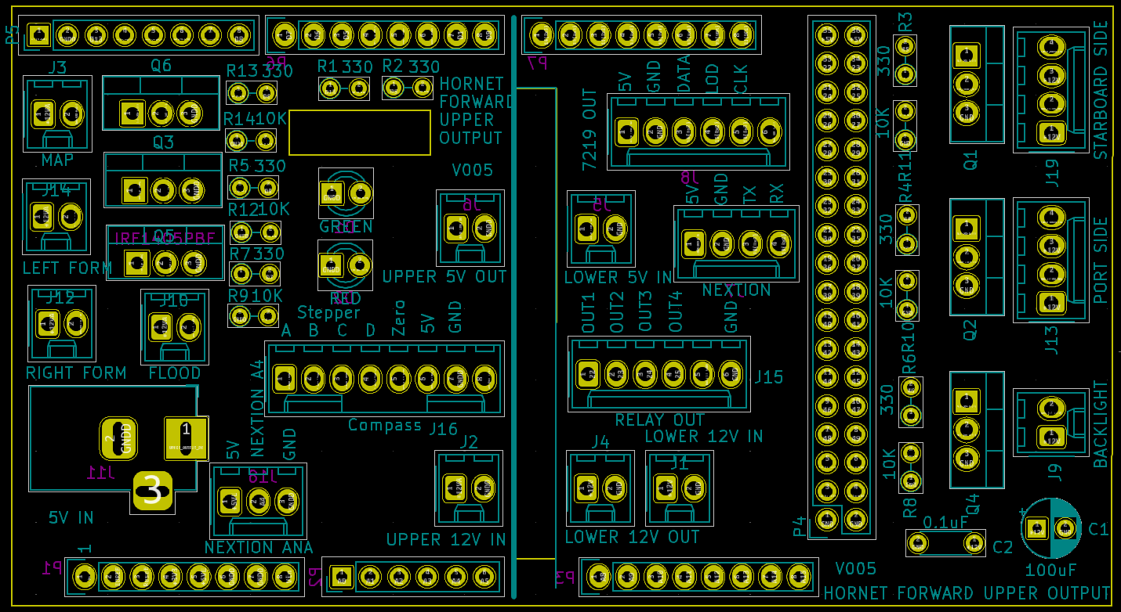Figure 1: Hornet Forward Output Upper Shield - PCB Layout
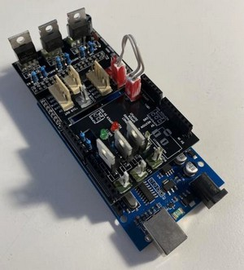
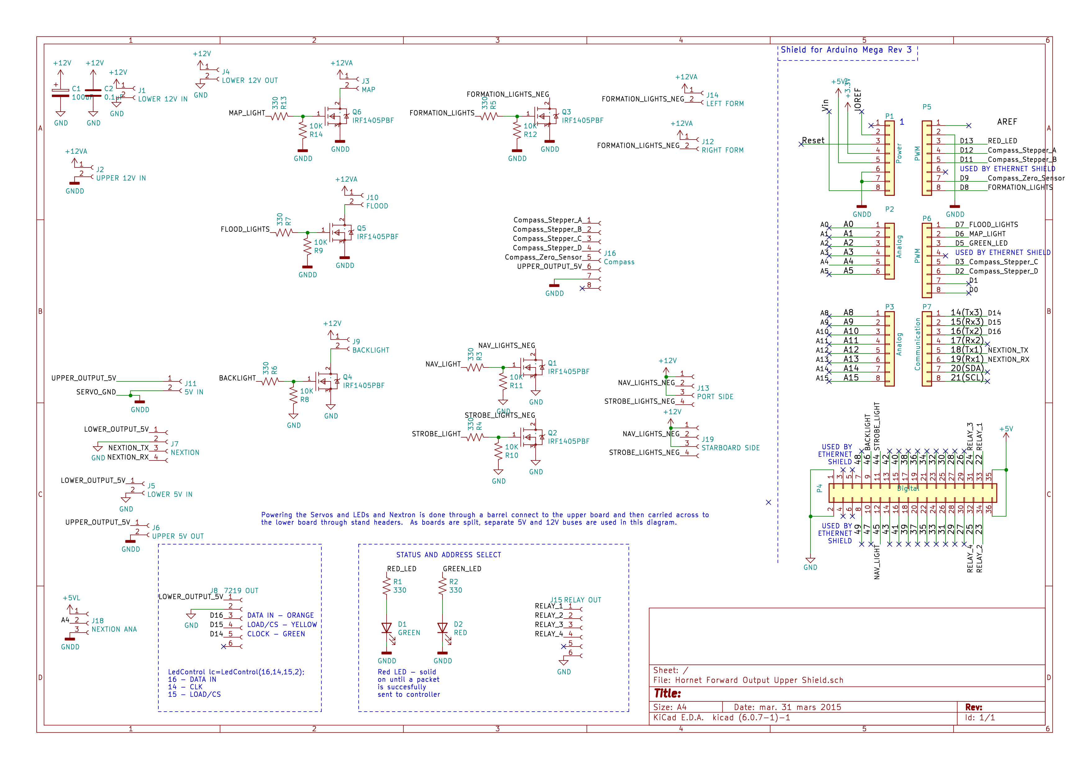Figure 2: Hornet Forward Output Upper Shield - Circuit Diagram
Connectors
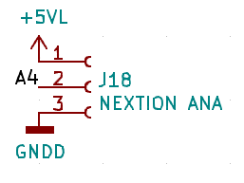 | The +5VL is 5V lower.  The Nextion is receive only for IFEI
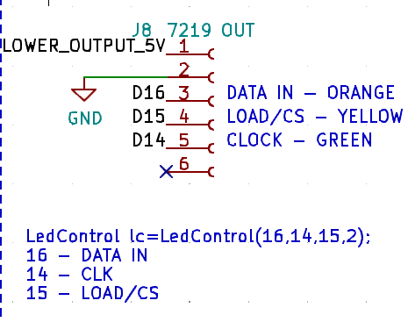
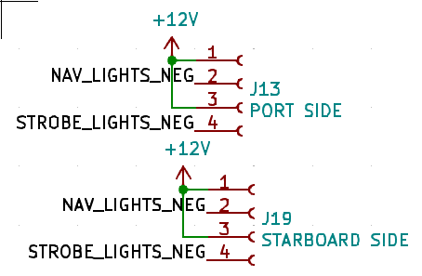
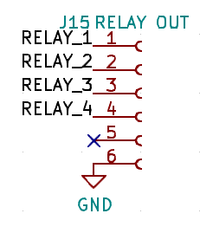
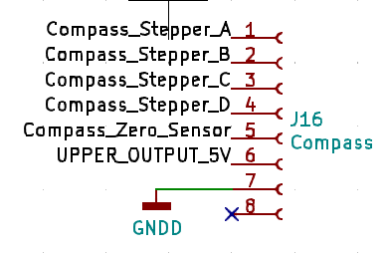

Building the Computer

Install Operating System
- Turn on visibility of hidden files and file extensions in explorer
- If using Samsung SSDs optionally install the Samsung Drive Monitoring Software
  - http://samsung.com/magician

Assign Static IP Address to Ethernet Connecting to Pit

Control Panel → Network and Internet → Network Connections. As the simple interface demands a default gateway and DNS be set, which is not used for this interface.
A static address (172.16.1.10/24) is used to receive switch events for MSFS 20202 as well as monitoring updates from the Arduino environment. If this address is not defined DCS interfaces will operate but updates may be slow due to the Arduino waiting for a timeout in resolving the ARP for the reflector. If it is not planned to use this link then is it recommended the following values be set to 0 in the Arduino code.
#define Reflector_In_Use 1
#define MSFS_In_Use 1

Install Documentation Tools
- These tools were chosen as they are cross-platform and lightweight
- LibreOffice - https://www.libreoffice.org/
- Draw.io – Offline installer – https://get.diagrams.net/.
  - Primary site - https://www.diagrams.net/

Install Development Environment
- Install Github –
  - http://desktop.github.com/
  - add primary repository -
    - https://github.com/bnepethomas/bne-arduino-flight-simulator-interfaces
- Instal Notepad++ https://notepad-plus-plus.org/downloads/
- Install Arduino IDE – including libraries used (built-in if author is not listed)
  - https://www.arduino.cc/en/software
  - FastLed 3.3.3 – Daniel Garcia
  - Ethernet – 2
  - Keyboard – 1.0.3
  - Mouse – 1.0.1
  - Servo 1.1.6 – Michael Margolis
  - Stepper 1.1.3
  - AccelStepper – 1.61.0 – Mike McCauley
  - Adafruit GFX Library – 1.2.2
  - Adafruit SSD1306 – 2.3.0
  - LedControl – 1.0.6 – Eberhard Fahle
  - Nextion – 2.0.2 – Helder Rodrigues
  - U8g2 – 2.27.6 – oliver
  - U8g2_for_Adafruit_GFX – 1.7.0 – oliver
- Install Python – minimum release 3.10 (for Case Statement support)
  - Add python.exe to PATH
  - Install python modules
    - pythonping (used in pyHWLink_System_Check.py)
    - SimConnect. Originally I had to use a fork on SimConnect, but the original project https://github.com/odwdinc/Python-SimConnect has now fixed the error, so using it.
      - Pip install SimConnect (0.4.26)
      - The module will be validated once MSFS 2000 has been installed.

Install Utilities

- Nirsoft Multi Monitor Tool
  - https://www.nirsoft.net/utils/multi_monitor_tool.html
- Nirsoft Device Viewer
  - https://www.nirsoft.net/utils/device_manager_view.html
- USB Tree View
  - https://www.uwe-sieber.de/usbtreeview_e.html#download
- Wireshark
  - https://www.wireshark.org/download.html
- Auto Logon from Sys Internals
  - https://learn.microsoft.com/en-us/sysinternals/downloads/autologon
  - Run autologon so login occurs automatically – may want to create a local acocunt.

Install Backup/Imaging Software
- Currently use Acronis True Image – but the perpetual licenses are no longer available – so may need to look for alternatives.

Install DCS

Install MSFS 2020
- Start MSFS 2020 and sign in
- Run ‘Python HW Link\pyHWLink_SimConnect_Transmitter.py’

Install Fly Elise
- Play the USB dongle in a port
- Install Fly Elise Display Pro (https://fly.elise-ng.net/immersive-display-pro/) Version 4.5.3
- Start Fly Elise Display Pro and Validate correct details are displayed in the license screen
- Install Fly Elise Calibration Pro Version 5.0.2. Download Zip, extract and then copy to a folder.
- Refer to “Building and Deploying A Curved Screen” for further details. Of note is the importance of allocating keystrokes to:
  - Start Warp
  - Stop Warp
  - Enable 2D Warping
  - Enable 3D Warping
- Start MSFS 2020 and validate screen is correctly displayed. MSFS SU10 enabled Surround and multiscreen support which improves the curved screen experience. Largely it reduces the distortion encountered ad the edges of the screen, ideally meaning lampposts are no longer leaning over. The Fly Elise team have noted that the surround view support still has room for improvement (as of Oct 2022).

Install Orbx Central
- Note different pits may operate under different accounts
- Download scenery of interest

Configure DCS
- Start DCS and load desired modules (eg Syria, Hornet)

Install and Configure Flight Panels DCS-BIOS
- Connect the pits USB port
- Statically assign COM Port numbers for the Arduino’s using the noting the Arduino Serial Numbers
- Ben’s document provides a useful guide to setting up Flight Panels DCS-BIOS fork (DCS-BIOS-FLIGHTPANELS.pdf)
  - THE FOLLOWING STEPS NEED TO BE VALIDATED!
  - Extract and copy the SOCAT.EXE to the programs directory within the git Repo
  - Edit the batch file to reflect the serial ports in use.
  - Add a taskbar shortcut to the CMD file – Pin a CMD/Batch file to the Task Bar in Windows

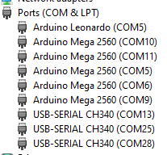

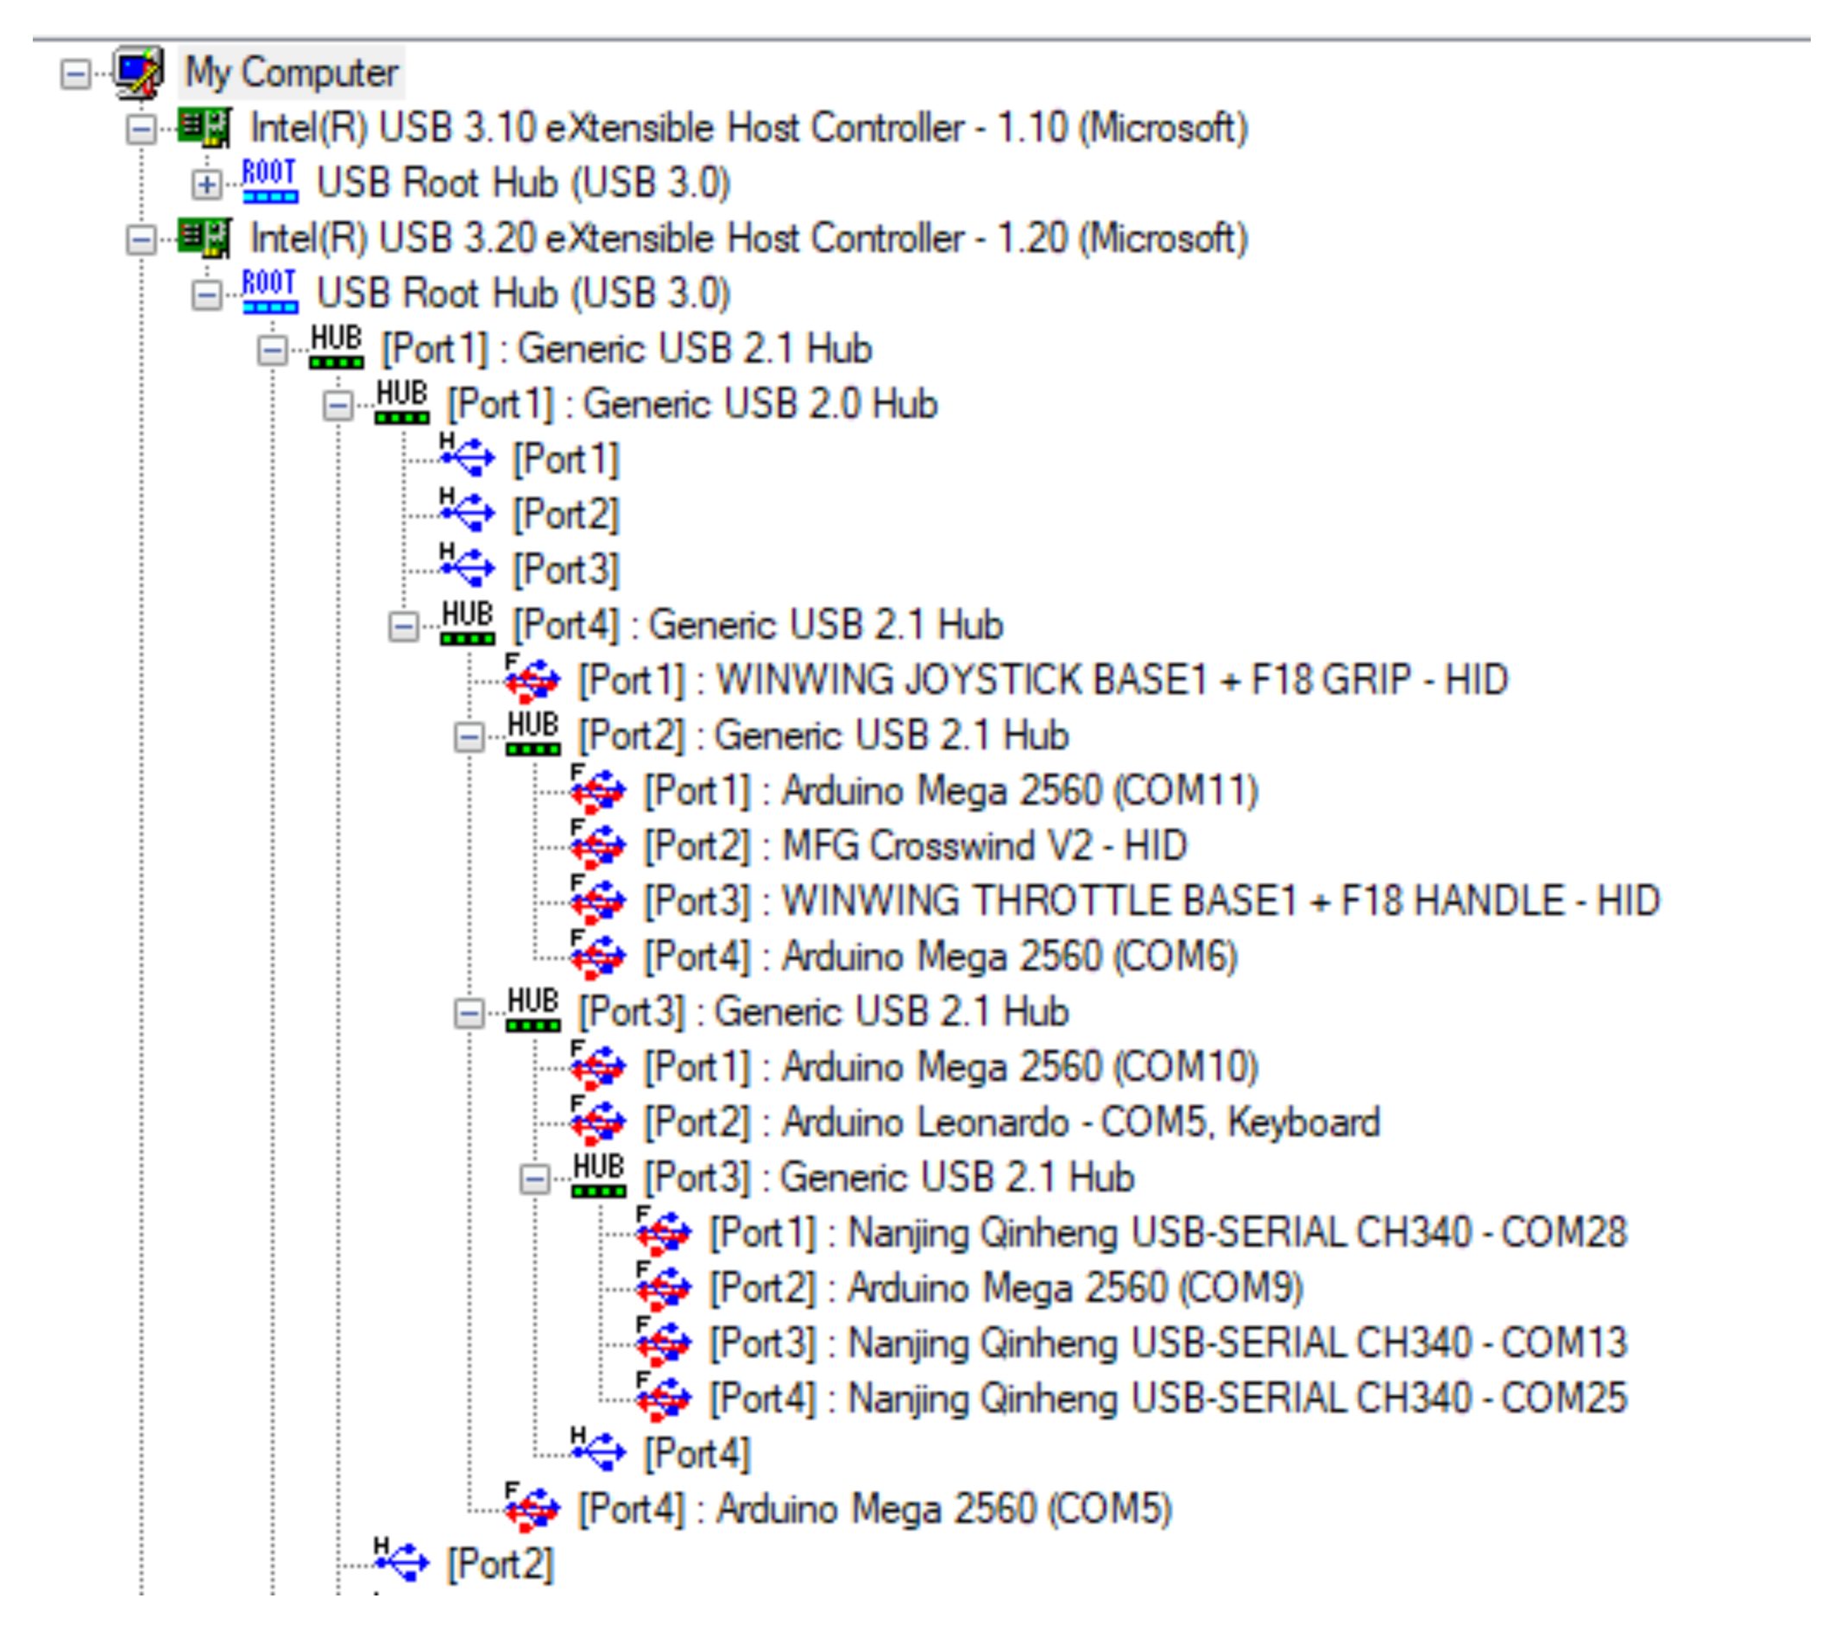

Monitor Layout and Standby Instruments

As there are multiple screens in the pit, and there will be times the pit will be removed to use the curved screen for other aircraft capturing screen positions is important (especially when using FlyElise). The Nirsoft MultiMonitor Tool allows you to save the screen layout. And restore it if needed.

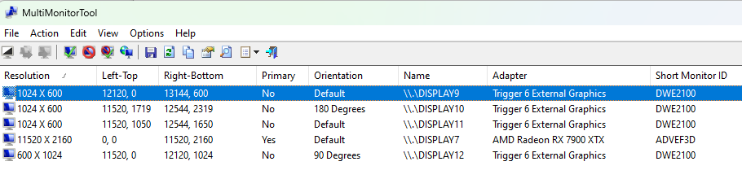

Mouse_Locator can be used to determine the current mouse position.
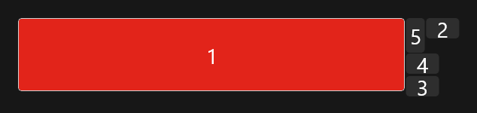

The following is an example monitor.lua file with multiple external views. Changes to the monitor.lua require a restart of the sim (you could reselect the monitor file in the gui
Explanation of Variables (as best as I know)

Variable | Use
x = 5760; | Location on computer – ie not tied to a screen
y = 0; | Location on computer – ie not tied to a screen
ViewRoll = 0; | Rolls the view – in radians
width = 1280; | Size of window
height = 400; | Size of window
viewDx = 3.15; | Horizontal rotation in Radians 3.15 is approx 180 degrees
viewDy = .5; | Vertical rotation in degrees, negative values looks down
aspect = 3.2; | Aspect ratio of rendered image
FOV = 1.5; | Zoom, larger number is zooming out
useAbsoluteFOV = true; | Locks the zoom
useAbsoluteAnglesShift = true; | Unsure
AnglesShift = 1; | Unsure

the total Screen Resolution for DCS is 13224x2319

The location of the primary menu can be set which is useful when FlyElise truncates a full screen. Minimum values for Width is 1400, and Height 900.
UI = { x = 1920, y = 0, width = 1920, height = 1080 }
UIMainView = UI
GU_MAIN_VIEWPORT = Viewports.Center
-_ = function(p) return p; end;
name = _('SIM18_0_0_11520_2160');
Description = 'Exported configuration with 3 projectors'

-- First value is top left corner of the screen
CENTER_MFCD = { x = 11520 + 0 , y = 0 + 445, width = 595, height = 590 }
LEFT_MFCD = { x = 12120 + 17, y = 0 + 30, width = 560, height = 590 }
RIGHT_MFCD = { x = 11520 + 460, y = 1050 + 30, width = 560, height = 580 }
F18_RWR = { x = 12097, y = 1814, width = 430, height = 450 }
F18_UFC = { x = 11522 , y = 0, width = 2, height = 2 }
F18_IFEI = { x = 11522, y = 3, width = 1, height = 1 }

Viewports =
{
P1 =
{
x = 0;
y = 0;
width = 3840;
height = 2160;
aspect = 1.777778;
useAbsoluteFOV = true;
useAbsoluteAnglesShift = true;
FOV = 2.116815;
viewDx = 1.228586;
viewDy = 0.037466;
},
P2 =
{
x = 3840;
y = 0;
width = 3840;
height = 2160;
aspect = 1.777778;
useAbsoluteFOV = true;
useAbsoluteAnglesShift = true;
FOV = 2.365660;
viewDx = 0.027072;
viewDy = 0.025351;
},
P3 =
{
x = 7680;
y = 0;
width = 3840;
height = 2160;
aspect = 1.777778;
useAbsoluteFOV = true;
useAbsoluteAnglesShift = true;
FOV = 2.146379;
viewDx = -1.225961;
viewDy = 0.029147;
}
}
--UIMainView = Viewports.P1
UI = { x = 5100, y = 100, width = 1400, height = 900 }
UIMainView = UI
GUI_MAIN_VIEWPORT = Viewports.P1

Viewports = {
Center = {
x = 0,
y = 0,
width = 1920,
height = 1080,
aspect = 1.77777777777778,
dx = 0,
dy = 0
}
}
UIMainView = Viewports.Center
GU_MAIN_VIEWPORT = Viewports.Center

Configure Keystroke Bindings for Magnetic Switches
Configure Monitors
- Now the Pit is installed we can complete configuration for the monitors and screens.
- Determine Monitor Layout. Optionally save the monitor layout using
- Configure Monitor related LUA files. Unfortunately DCS doesn’t provide a simple way to configure multiple monitors.
- Configure RWR – can add rings https://forum.dcs.world/topic/241306-fun-with-rwr-exporting-and-a-question-on-scaling-a-texture-through-lua/
- Edit - D:\Program Files\Eagle Dynamics\DCS World\Mods\aircraft\FA-18C\Cockpit\Scripts\TEWS\indicator\RWR_ALR67_MAIN_page.lua
dofile(LockOn_Options.script_path.."TEWS/indicator/RWR_ALR67_definitions.lua")

-- Uncommented these - PT 20221229
addStrokeCircle("TEST_CIRCLE", 1, {0, 0})
addStrokeCircle("TEST_CIRCLE_1", 0.74, {0, 0})
addStrokeCircle("TEST_CIRCLE_2", 0.56, {0, 0})
addStrokeCircle("TEST_CIRCLE_3", 0.19, {0, 0})
addStrokeCircle("TEST_CIRCLE_0", 0.075, {0, 0})

AddPrioritySetting(STROKE_FNT_DFLT, {-0.1, 0.05})
AddBitFailures(STROKE_FNT_DFLT, {0, -0.05})
AddLimitModeLabel(STROKE_FNT_DFLT, {0.1, 0.05})

local boat_y = -0.075
local specScaleX = 0.0065
local specScaleY = 0.006
for i = 1, 16 do
local num = i-1
AddThreatPlacer("RWR", num, nil, true)
AddThreatSymbol("RWR", STROKE_FNT_DFLT, num)

AddBoatHarmSymbols("RWR", "stroke_symbols_MDI_AMPCD", num, boat_y, {"scale", specScaleX, specScaleY})
end

add this to line 79 & 80 of file RWR_ALR67_init
D:\Program Files\Eagle Dynamics\DCS World\Mods\aircraft\FA-18C\Cockpit\Scripts\TEWS\indicator\RWR_ALR67_init.lua

dofile(LockOn_Options.common_script_path.."ViewportHandling.lua")
try_find_assigned_viewport("F18_RWR")

Addition work is then need to modify the way lines are drawn – otherwise you end up with a big blob. The easiest way to resolve this is to expand the TEWS.zip file to DCS World\Mods\aircraft\FA-18C\Cockpit\Scripts. It contains the following
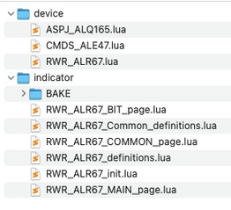

The major thing of note is the line width needs to be reduced otherwise the view looks very blobby.

shaderLineParamsUpdatable = true
shaderLineDefaultThickness = 0.01
shaderLineDefaultFuzziness = 0.014
shaderLineDrawAsWire = false
shaderLineUseSpecularPass = true

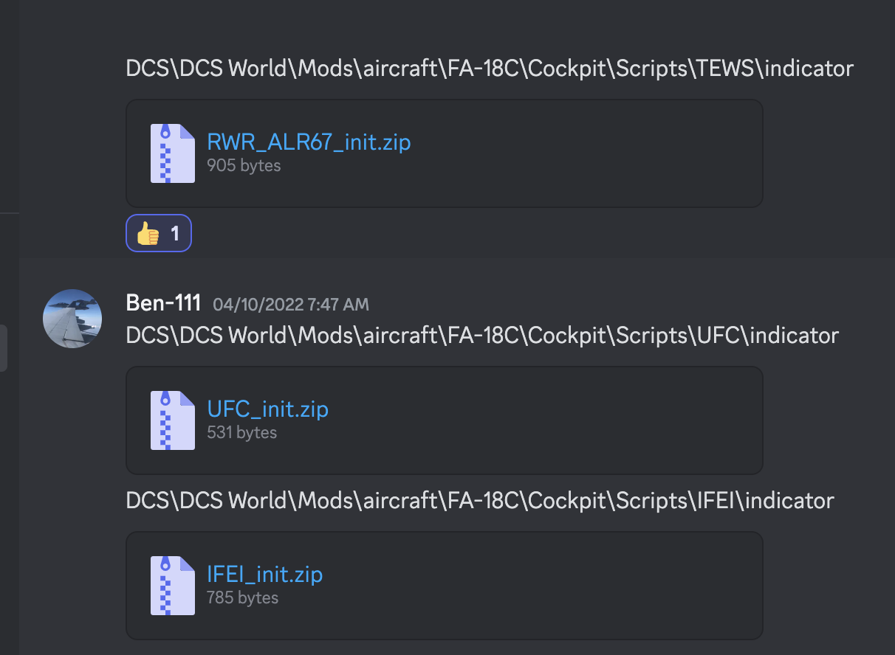

As the cockpit is ‘hidden’ in the Sim modifications are needed to ensure that the RWR is drawn and data is populated in DCS BIOS for UFC and IFEI. If you don’t update the IFEI file you’ll see some data being updated in the IFEI but not all.

DCS\DCS World\Mods\aircraft\FA-18C\Cockpit\Scripts\TEWS\indicator
RWR_ALR67_init.zip

A little more complicated than the UFC and IFEI – so may just just easiest to copy the file

dofile(LockOn_Options.common_script_path.."ViewportHandling.lua")
indicator_type = indicator_types.COMMON
purposes = {render_purpose.GENERAL}
local x_size = 1
local y_size = 1
function update_screenspace_diplacement(zoom_value)
local default_width = 0.5 * LockOn_Options.screen.height + (64 * zoom_value)
if default_width > LockOn_Options.screen.height then
default_width = LockOn_Options.screen.height
end

if default_width > 0.5 * LockOn_Options.screen.width then
default_width = 0.5 * LockOn_Options.screen.width
end

local default_height = (y_size/x_size) * default_width
local default_y = LockOn_Options.screen.height - default_height
local default_x = LockOn_Options.screen.width - default_width

dedicated_viewport = {default_x,default_y,default_width,default_height}
dedicated_viewport_arcade = {default_x, 0 ,default_width,default_height}
end
update_screenspace_diplacement(0)
function set_full_viewport_coverage(viewport)
dedicated_viewport = {viewport.x,
viewport.y,
viewport.width,
viewport.height}
dedicated_viewport_arcade = dedicated_viewport
purposes = {render_purpose.GENERAL,
render_purpose.HUD_ONLY_VIEW,
render_purpose.SCREENSPACE_OUTSIDE_COCKPIT,
render_purpose.SCREENSPACE_INSIDE_COCKPIT} -- set purposes to draw it always
render_target_always = true
end
-- try to find assigned viewport
local multimonitor_setup_name = "Config/MonitorSetup/"..get_multimonitor_preset_name()..".lua"
local env = {}
env.screen = LockOn_Options.screen
local f = loadfile(multimonitor_setup_name)
if f then
setfenv(f,env)
pcall(f)

local vp = nil
vp = env.F18_RWR

if vp ~= nil then
dbg_print("ok we have directly assigned viewport to MFCD\n")
set_full_viewport_coverage(vp)
end
end
shaderLineParamsUpdatable = true
shaderLineDefaultThickness = 0.01
shaderLineDefaultFuzziness = 0.014
shaderLineDrawAsWire = false
shaderLineUseSpecularPass = true
opacity_sensitive_materials =
{
"font_RWR",
"RWR_STROKE"
}

DCS\DCS World\Mods\aircraft\FA-18C\Cockpit\Scripts\UFC\indicator
UFC_init.zip

Add to the end of the file
--ViewportHandling
--ViewportHandling
dofile(LockOn_Options.common_script_path.."ViewportHandling.lua")
update_screenspace_diplacement(1, true, 0)
try_find_assigned_viewport("F18_UFC")
dofile(LockOn_Options.common_script_path.."ViewportHandling.lua")
update_screenspace_diplacement(1, true, 0)
try_find_assigned_viewport("F18_UFC")

DCS\DCS World\Mods\aircraft\FA-18C\Cockpit\Scripts\IFEI\indicator
IFEI_init.zip

Add to the end of the file
--ViewportHandling
dofile(LockOn_Options.common_script_path.."ViewportHandling.lua")
update_screenspace_diplacement(1, true, 0)
try_find_assigned_viewport("F18_IFEI")

Tuning HUD

This is currently work in progress
D:\Program Files\Eagle Dynamics\DCS World\Mods\aircraft\FA-18C\Cockpit\Scripts\materials.lua

local MDG_materials = {}
MDG_materials[MDG_SELF_IDS.HUD] = {223, 1, 1, 355} -- PT Red

Increasing the width of the lines for hud makes it more visible – it does however make the DDIs fuzy – hopefully there is an option to use different stroke widths for the DDIs and HUD

D:\Program Files\Eagle Dynamics\DCS World\Mods\aircraft\FA-18C\Cockpit\Scripts\Multipurpose_Display_Group\Common\indicator\MDG_strokesDefs.lua

ofile(LockOn_Options.script_path.."config.lua")

stroke_thickness = 2.8
stroke_fuzziness = 0.0

if bakeIndicators == true then
DMC_stroke_thickness = stroke_thickness
DMC_stroke_fuzziness = stroke_fuzziness

-- Currently is used for DMC generated fonts black outline
--DMC_outline_thickness = stroke_thickness * 3
--DMC_outline_fuzziness = stroke_fuzziness * 1.1

-- valid for cockpit view, but looks overdone at HUD only view
DMC_outline_thickness = stroke_thickness * 4
DMC_outline_fuzziness = stroke_fuzziness * 1.4
else
DMC_stroke_thickness = 0.65
DMC_stroke_fuzziness = 0.0

-- Currently is used for DMC generated fonts black outline
DMC_outline_thickness = stroke_thickness * 3
DMC_outline_fuzziness = stroke_fuzziness * 1.1
end

Duplicating files for DCS Open Beta
Set up credentials, save and auto logon
Copy IFEI, UFC and TEWS files
copy monitor setup files, MiddleScreen.lua (just uses the central screen), and MonitorSetup.lua to Config → MonitorSetup.
Select MiddleofScreen for Monitor setup
Set the resolution to 13224x2319
Then select ok or press enter to commit changes
Once this looks ok select SIM18_0_0_11520_2160
Remove conflicting keystrokes for WARP from DCS
Adjust and save default view angle RALT+Num0
L-Ctrl-L-Alt-F6 to bring up performance graph, should be a minimum of 24fps with stable frame time (ie not jumping around)
If performance goes down to 4 fps – toggle warp – it may take a couple of goes
Copy Saved Games\DCS\Scripts to Saved Games\DCS Open Beta\Scripts
Add Key Bindings for Open Beta
Set Rudder pedal toe brakes
Set Afterburner position in throttle

Optionally add the following in export.lua to enable GPS connectivity
package.path = package.path..";.\\LuaSocket\\?.lua"
package.cpath = package.cpath..";.\\LuaSocket\\?.dll"

socket = require("socket")

gps_export_port = 13136
gps_export_host = "192.168.2.30"
gps_export_socket = require("socket")
gps_export_con = socket.try(gps_export_socket.udp())
gps_export_socket.try(gps_export_con:settimeout(.001))
gps_export_socket.try(gps_export_con:setpeername(gps_export_host,gps_export_port))

function LuaExportActivityNextEvent(t)

local tNext = t
local gps_export_flightData = {}
-- LATITUDE
table.insert(gps_export_flightData,"latitude:"..LoGetSelfData().LatLongAlt.Lat)
-- LONGITUDE
table.insert(gps_export_flightData,"longitude:"..LoGetSelfData().LatLongAlt.Long)
-- ALTITUDE SEA LEVEL(MTS TO FT)
table.insert(gps_export_flightData,"altitude:"..LoGetAltitudeAboveSeaLevel())
-- TRUE AIRSPEED (M/S TO KNOTS)
table.insert(gps_export_flightData,"airspeed:"..LoGetTrueAirSpeed() * 1.94)
-- HEADING (RAD TO DEG)
table.insert(gps_export_flightData,"magheading:"..LoGetSelfData().Heading * 57.3)
gps_export_packet = gps_export_flightData[1] .. "," .. gps_export_flightData[2] .. ","
gps_export_packet = gps_export_packet .. gps_export_flightData[3] .. ","
gps_export_packet = gps_export_packet .. gps_export_flightData[4] .. ","
gps_export_packet = gps_export_packet .. gps_export_flightData[5]
gps_export_socket.try(gps_export_con:send(gps_export_packet))

tNext = tNext + 1.0
return tNext

end

ReMap Comm Ports to documented values

For simplified troubleshooting and consistency when programming the Arduino map the Arduino Com Ports to that documented.

Run USB View as Administrator and select Properties, and then Advanced to change Comm Port Mapping

Applying DCS Updates

It is common for DCS to update the LUA files associated with the TEW and one other of the outputs. A reasonable approach is to keeping a renamed copy of the master in the same directory and then copying it over the updated files.
The script to copy the files is in the github repo – the PC has a shortcut to the cmd file on the desktop

echo Copy Configuration files
echo Had to change file attributes from read only and change permissions to mods sub directories
echo CDU
copy .\IFEI_init.lua "D:\Program Files\Eagle Dynamics\DCS World\Mods\aircraft\FA-18C\Cockpit\Scripts\IFEI\indicator\IFEI_TIME_SET_page.lua"

copy .\UFC_init.lua "D:\Program Files\Eagle Dynamics\DCS World\Mods\aircraft\FA-18C\Cockpit\Scripts\UFC\indicator"
pause

Building Tools
Tools used in the build include:
- Prusa MK3 filament printer
- Full Spectrum 30W CO₂ Laser
- Creality Resin Printer

Components Used
Table of Contents
Components Used 37
Backlighting 38
Connectors 38
Display 39
External Connectors 39
Left Console – Comms Panel 41
Miscellaneous 41
Mirrors 42
LIP 42
Printing Support 43
Right Console 44
Rudder Pedal Mounts 45
Tools 46
UFC 48

Backlighting

Connectors
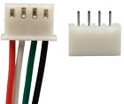 | 50sets Micro JST XH 2.54 2-8/10Pin 24AWG Single End 15cm Wire To Board Connector  Cost $10  Note – the bulk of the connectors used in the project where JST, a small number of locations needed the Micro JSTs
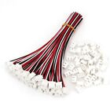 | 50Sets XH2.54 3Pin Single-Head Wire To Board Connector 15cm 24AWG With Socket  Cost $20
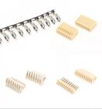 | KF2510 2P-12P 2.54mm Straight/Right Angle Pin Header Housing Connector Terminals  Cost $10

Display
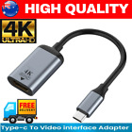 | 4K Type C to HDMI Adapter 30Hz USB C 3.1 Male to HDMI Female Cable FOR MACBOOK m  Cost $11
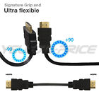 | Ultra Flexible HDMI Cable 1M 10M 5M High Speed 1080p High Definition HD AU Stock  Cost $17

External Connectors
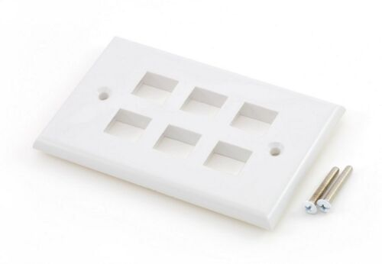 | Keystone wall plate - 6 port white  Cost $3  Supplier - homewired
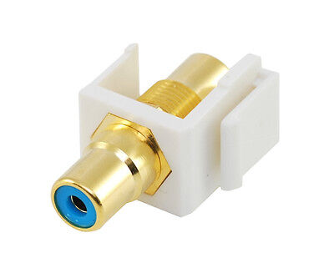 | RCA keystone coupler - blue  Cost $4  Supplier - homewired
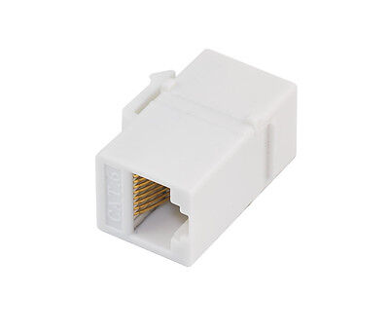 | Cat6 RJ45 Keystone Inline Coupler * 2  Cost $7  Supplier - homewired
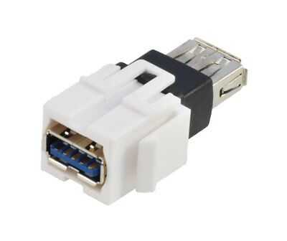 | USB 3.0 keystone coupler * 4  Cost $18  Supplier - homewired
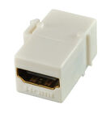 | HDMI keystone coupler - 1.4 and 2.0 compatible  Cost $10  Supplier - homewired
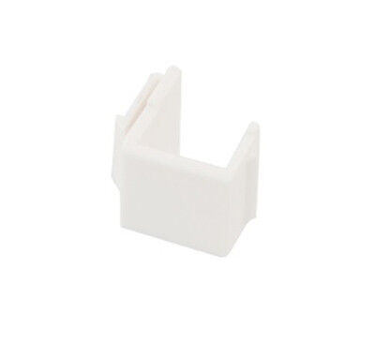 | Blank keystone inserts x 4  Cost $3  Supplier - homewired

Left Console – Comms Panel
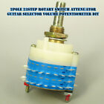 | 2pole 23step Rotary Switch Attenuator Guitar Selector Volume Potentiometer DIY  Cost - $20  Note – Alternate pins from the upper and lower decks are needed to be used at this switch is a make before break
 | LED Clearance Lights Side Marker Lamps White Amber Red Trailer Truck RV 12V-24V  Cost $11  Used for external lamps

Miscellaneous
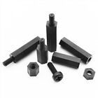 | 25/100pcs Black Plastic Nylon M2 M3 M4 Hex Column Standoff Spacer Phillips Screw  Cost $4
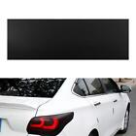 | Matt Black Car Light Headlight Taillight Tint Vinyl Film Sticker Sheet Lamp Film  Cost $11
Nuts and Bolts | Gateway bridge Brisbane  https://www.boltandnut.com.au/
Possible knob supplier | electroenterprises  MS21385-04CNN  https://www.electroenterprises.com/
 | https://www.digikey.com.au
 | https://au.element14.com
 | https://au.mouser.com

Mirrors
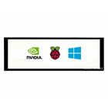 | 7.9inch Capacitive Touch Screen LCD 400×1280 HDMI IPS Toughened Glass Cover  Cost $105

LIP
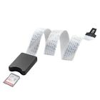 | TF Micro SD to SD Card Extension Cable Extender Adapter SDHC For Car GPS TV 62cm  Cost $11

Printing Support
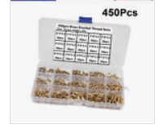 | 450Pcs Female Thread Knurled Nuts M2 M3 M4 Brass Threaded Insert Round  Cost $25
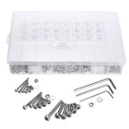 | OZ 1080PC Stainless Steel Screws Bolts and Nuts Assortment M2/M3/M4/M5 Hex Head  Cost $38
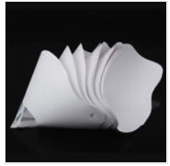 | Funnel Filter Paper 3D Printer Resin Disposable Photocuring Consumable  Cost $13

Right Console
 | 10x T10 194 168 SMD 5050 LED Car Wedge Tail Side Parking Light Globe 12V – WHITE  Cost $10  Used in forward flood light
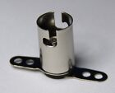 | Light Socket for BA9S 1895 T4W 57 182 Globes and LEDs (Pack of 10)  Cost $8  Used in most of the flood lights
 | 10x BA9S BAYONET LED LIGHT BULB 5SMD 5050 WHITE PARKER CAR GLOBE INTERIOR 12V  Cost $9  Used in most of the flood lights
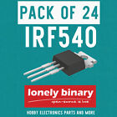 | LONELY BINARY N-Channel Power Mosfet IRF540 LOGIC LEVEL UNO R3 MEGA 2560 ESP32  Cost $25

Rudder Pedal Mounts

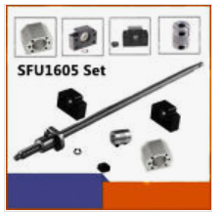 | Ball Screw  BallScrew 1605 L250~2000mm SFU1605 End Machine &BK/BF12 &Nut Housing&Coupler Set  https://www.ebay.com.au/itm/393273532995?  Cost ~ $53
 | Linear Rail Set  2X SBR16 300-2000MM Linear Rail Guide Slide Shaft Rod 4X SBR16UU Bearing Blocks  Cost ~ $53
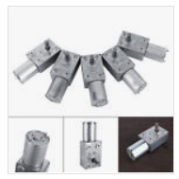 | DC12V-Metal Gear High Torque Turbine Turbo Worm Geared Reduction Motor 2-100RPM  Cost ~ $19

Tools
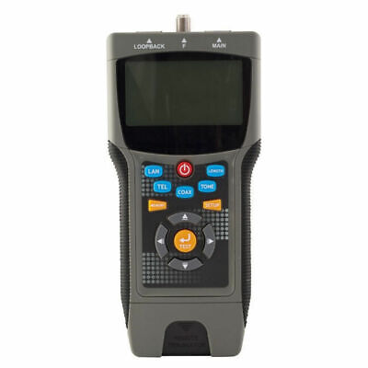 | Doss Pro Coax & Lan Cable Tester Locates Distance to the Fault Coaxial Wire LCT8  Cost $209
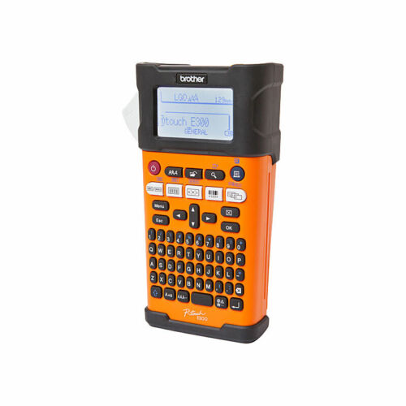 | Brother PT-E300VP Industrial Labelling Machine W Li-ion Battery Heat Shrink Tape  Cost $226  As the heatshrink tape is relatively expensive, use multiple line prints, this considerably reduces the amount of heatshrink used.  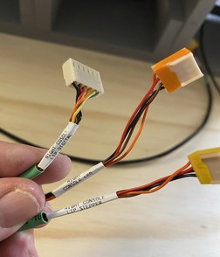
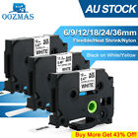 | Compatible with Brother Heat Shrink Tube HSE231 12mm Label Tape for P-Touch E300  Cost $14
 | 2in1 Soldering Solder Station Rework Iron Hot Air Gun Digital SMD Desoldering-AU  Cost $90
 | IWISS PH2.0 XH2.54 Dupont KF2510 JST Terminal Ratchet Crimper (SN28B + SN01BM)  Cost $73
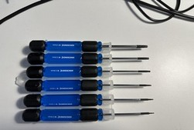 | Sidchrome Hex drivers from Bunnings.

UFC
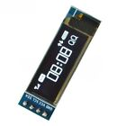 | 0.91 inch IIC I2C SPI 128x32 White OLED LCD Display Module For Arduino PIC G3G8  Cost $6
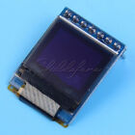 | 0.66 inch White 64x48 OLED Display Module SPI I2C 3.3-5V for Arduino AVR STM32  Cost $5
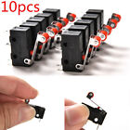 | 10Pcs Micro Roller Lever Arm Open Close Limit Switch Kw12-3 PCB Microswitch Hot  $3

Tip and Tricks

Working with Github

If you just wanty to download an individual folder from Github just use GitZip
https://kinolien.github.io/gitzip/
This is useful when you are unable to download large repo such as OpenHornet due to a randmo local issue or its just about doing it quickly

Documentation

Use the Github Web GUI to search for instances of a name across multiple arduino projects. It has the benefit of not having to open multiple instances on sketch editors and copy and paste is always plain text.

Pin a CMD/Batch file to the Task Bar in Windows
Reference - https://winaero.com/pin-a-batch-file-to-the-start-menu-or-taskbar-in-windows-10/
Here is what you need to do.
Right click on the Desktop and select the command "New -> Shortcut" from the context menu.
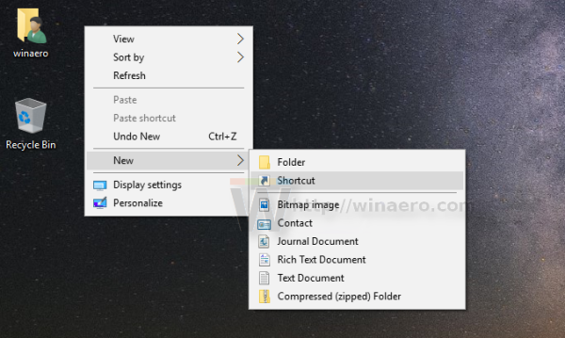
In the shortcut target, type the following text:
cmd /c "full path to your batch file"
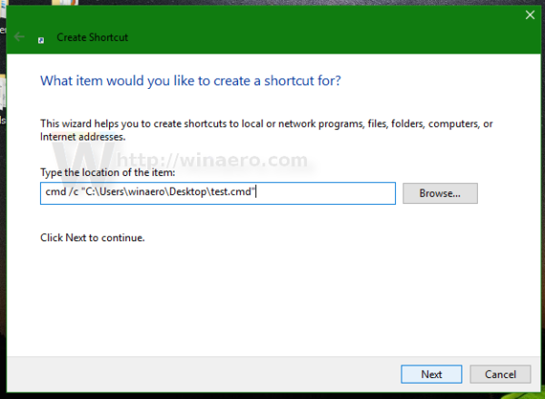
- Name the shortcut and change its icon if you need: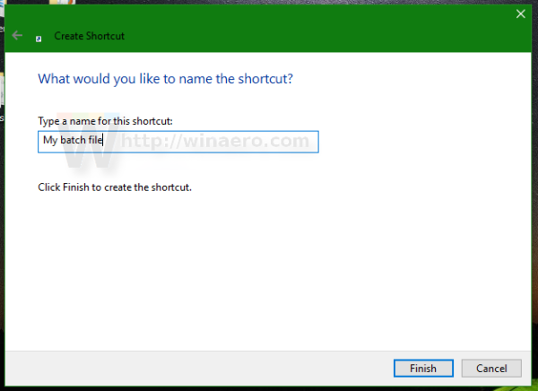
- Now, right click the shortcut and choose "Pin to Start" from the context menu: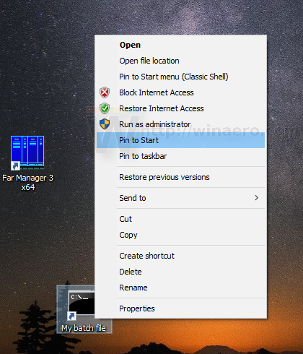

Configuring Monitors using Helios

  - We will be using Helios for the Monitor Configuration (so monitors need to be connected at this point, or at least make a note you’ll need to rerun Helios after they are connected.
  - Download installer link - https://github.com/HeliosVirtualCockpit/Helios/releases/latest
  - Extract ZIP and run Helios MSI installer (Version 1.6.56000.0)
  - We will first use a default profile to validate we can display data from Helios- and then use a customised profile. If you are familiar with Helios this steps using Captain Zeen’s profile can be skipped.
  - Grab desired Profiles from Captain Zeen’s site http://www.captzeen.com/helios/downloads.asp
    - Using CaptZeen_FA18C_V3.1.helios16
  - Click on the download profile, and Helios will install it.
  - Open the profile in Helios Profile Editor
  - You’ll get a bunch of warnings, work through the warning displayed on Interface Status
    - Add/configure DCS A10C impersonating FA-18C_hornet (click the gear in the top right hand corner). Helio didn’t like the DCS-BIOS entry in the script, so copy original export.lua to another file – need to re-add DCS-BIOS
    - DCS Additional View Ports (click the gear in the top right hand corner)
    - DCS Monitor Setup – following the bouncing ball, noting the Resolution that must be selected in DCS.
    - Save Profile
    - Start Helios – select the profile – good idea to turn on the console – it flagged a couple of warnings
      - Resolution in System Settings needed to be increased
      - Need to select Helios in Monitor configuration
      - Updated these settings in DCS
      - Without Helios running we should see the view ports in action
      - The two things to validate is the ADI and RWR working – as they will be used for the Standby instruments
      - Add the DCS-BIOS entry into export.lua – validate both DCS-BIOS and Helios are functional.
    - Defining the Standby Instruments Profile
      - When modifying view ports you are shifting its output from within the DSC Cockpit to another location. This means instruments will ‘disappear’ from the in game cockpit view. Noted this with RWR
      - Manually Defining a Profile - https://www.youtube.com/watch?v=-1z3W2DauCs – useful reference. If a DCS Monitor output is defined another another profile that has been activated, it will be displayed even it you have not defined it.
        - Create a new one
        - Save it – ‘Standby Instruments’
        - Add Interface - DCS Monitor Setup
        - Add Interface DCS FA-18C
        - Add SAI Gauge to monitor
        - In the Bindings Frame
          - Scroll Down to Bindings
          - On SAI – Drag (as you Bind Values a ‘>’ will appear to the left of the binding).
            - Pitch hanged to setPitch
            - Bank changed to setBank,
            - Slip Ball changed to set Slip Ball Offset
            - Warning Flag Changed to Set Off Flag,
          - Run Helios Control Panel, select the profile, and good idea is ro turn on the console to monitor log messages.
        - Adding Viewports. If you drag the desired viewport onto the monitor without selecting the DCS Monitor Setup – the viewport will not be displayed
          - Add the following Interfaces
            - DCS Monitor Setup
            - DCS Additional Viewports
        - Ensure DCS is using the Helios Monitor Profile.

Useful URLS

https://www.openflightschool.de/
Lots of tips and tricks
https://www.openflightschool.de/mod/book/view.php?id=236

https://forum.dcs.world/topic/134049-3-monitor-setup-moving-all-radio-texts-to-center-screen/
Adjusting ATC menu position
https://forum.dcs.world/topic/258724-how-to-multi-monitor-mfcd-display-export-set-up-guide-nov-2022-updated/

https://winaero.com/pin-a-batch-file-to-the-start-menu-or-taskbar-in-windows-10/
Pin a CMD/Batchfile to the Taskbar

Plane Spotting

https://aircraftnoisemap.airforce.gov.au/assets/site.html?384#base/5/region/77/events

http://aussieadsb.com/airspaces?fbclid=IwAR3qWMav7fapFhkGdy8n6r5MlbFH38-_HqVpLdtuZBgai6TSzfANd0g0efg

Table of Figures
Figure 1: Hornet Forward Output Upper Shield - PCB Layout 26
Figure 2: Hornet Forward Output Upper Shield - Circuit Diagram 26

MAC address 4th Octet is hex of IP Address 4th Octet
Ethernet not in use on UFC OLED
Temporary until new Right Output PCB Arrives.
https://www.amazon.com.au/dp/B0772Q3LRD
https://github.com/bnepethomas/bne-arduino-flight-simulator-interfaces/blob/master/Hornet/Hornet%20DCS%20Configuration%20Files/reset_Hornet_display_configurations.cmd

